Installation & Commissioning of ETAP-RT System

Functional Design Specifications (FDS)

CURRENT REVISION:
REV. | DATE | PREPARED BY | TITLE | DEPARTMENT | DESCRIPTION
0 | 5-14-2019 | Frank Zhang | Sr. Automation and Control Engineer | Automation

APPROVED FOR SUBMISSION:
NAME | TITTLE | DEPARTMENT | DATE | SIGN | DOCUMENT PREPARED FOR:
Hugo Castro | VP-AUTOMATION | Automation |  |  | □ Information only
Susama Bagchi | SG Program Manager | Smart Grid |  |  | Comments requested
 |  |  |  |  | □ Comments Required
 |  |  |  |  | □ Final Document

CLIENT’S APPROVAL:
NAME | TITTLE | DEPARTMENT | DATE | SIGN | RESPONSE:
Dr. Rosli Lajim | Program Manager | TNB |  |  | □ Resubmit, work may proceed
 |  |  |  |  | □ Resubmit, work may NOT Proceed
 |  |  |  |  | □ Held as reference
 |  |  |  |  | □ Final document

Table of Contents
1. Introduction 6
1.1 Executive Summary 6
1.2 Definitions, Abbreviations, and Acronyms 6
1.3 Intended Audience 6
1.4 How to Read This Document 6
1.5 References 7
2 Project Objective 8
2.1 Background 8
2.2 Requirements and Expectation 8
3 Project Scope 9
3.1 Team Organization 9
3.1.1 SG Team 9
3.1.2 ETAP Team 9
3.1.3 TNB PM and Technical Team 9
3.2 Scope of Work 10
3.2.1 JSC-SG and ETAP 10
3.2.2 TNB 10
4 Hardware Requirement 11
4.1 ETAP Server Specification 11
4.2 ETAP Engineering and Operating Work Station Specification 11
5 System Overview 12
5.1 ETAP Model 12
5.1.1 Single Line Diagrams 12
5.1.2 Data Import 12
5.2 System Architecture 13
5.2.1 Components 14
5.3 Authorization 14
5.3.1 User Levels 14
5.4 Graphical Representation 15
5.4.1 Primary Presentation 15
5.4.2 Sys Simulation presentation 16
5.5 Composite network presentations 16
6 Software Overview 17
6.1 ETAP 17
7 ETAP Applications 18
7.1 Overview 18
7.1.1 Applications 18
7.1.2 Exceptions to Specifications 18
7.1.3 Base Mode 19
7.1.4 Basic Design Premises 19
7.1.5 System Overview 19
7.1.6 Data Editing 19
7.1.7 Graphics Editing 20
7.1.8 Mouse and Keyboard Functions 20
7.1.9 Adding Components 21
7.1.10 Presentation Functions 22
7.1.11 System Continuity Check 22
7.1.12 Configure SCADA Integrator 22
7.2 SLE - State and Load Estimator 23
7.2.1 Data Requirements 23
7.2.2 Real Measurements 23
7.2.3 Pseudo Measurements 23
7.2.4 Pinned Measurements 23
7.2.5 Weight Factor 24
7.2.6 Location and Number of Measurements 24
7.2.7 SLE Convergence 25
7.3 Unbalanced Load Flow 25
7.3.1 Unbalanced Load Flow Toolbar 26
7.3.2 Unbalanced Load Flow Study Case 29
7.3.3 Display Options 46
7.3.4 Alert Viewer 60
7.3.5 Output Reports 61
7.4 Distribution State Estimation (DSE) 66
7.4.1 Load Allocation Configuration 69
7.5 Volt-Var Optimization 72
7.5.1 Local Vs Centralized Volt-Var Optimization: 72
7.5.2 VVO Toolbar 74
7.5.3 Study Case Design 75
7.5.4 Results Display for VVO 86
7.5.5 Output Reports for VVO 92
7.5.6 VVO Web Application 93
7.6 Optimal Capacitor Placement (OLD only) 94
7.6.1 Optimal Capacitor Placement Toolbar 95
7.6.2 Optimal Capacitor Placement Study Case 97
7.6.3 Display Options 110
7.6.4 Output Reports 113
7.6.5 Plots 118
8 PSMS Typical 121
8.1 Power Grid 121
8.2 Bus 121
8.3 Generator 121
8.4 Transformer 121
8.5 High voltage circuit breaker 122
8.6 Switch 122
8.7 Lumped Load 123
8.7.1 Multi-Meter 123
8.7.2 Capacitor Bank 123
8.7.3 Cable 123
8.7.4 Low Voltage Circuit Breaker 123
8.7.5 Induction Motor 124
9 Factory Acceptance Test 125
10 User Acceptance Test 126

Introduction

Executive Summary
This is a research project cooperating among ETAP, JSC Tech-Smart Grid, and TNBR, which intends to install Volt-Var optimization engine in TNB’s distribution system and check the effectiveness after implementing the engine’s recommendation based on different objectives. This document intends to provide the functional design specification on each of the modules for this project.

Definitions, Abbreviations, and Acronyms
Abbreviations | Definition
ETAP | Electrical Transient Analyzer Program (ETAP) Software
ETAP-A | ETAP Automation
ETAP PSMS Model | Electrical model generated in ETAP that serves as the base for all calculations in the program.
OEC | Operating and Engineering Consoles
FAT | Factory Acceptance Test
GUI | Graphical User Interface
I/O | Input / Output
OCP | Optimal Capacitor Placement
OLV | One-Line View
OLD | One-Line Diagram
OPC | OLE for Process Control
PSMS | Power System Monitoring & Simulation
SAT | Site Acceptance Test
SCADA | Supervisory Control and Data Acquisition
SLE | State and Load Estimator
SQL | Structured Query Language
SG | Smart Grid Sdn. Bhd.
TNB | Tenaga Nasional Berhad
VVO | Volt-Var Optimization
DSE | Distribution State Estimation
LA | Load Allocation

Intended Audience
This document has been prepared for the following audience:
- JSC Tech - Smart Grid Sdn. Bhd. Team
- Tenaga Nasional Berhad Team
- ETAP Automation Team

How to Read This Document
This document follows the structure below:
- Introduction
- Project Objective
- Project Scope
- Hardware Requirement
- System Overview
- Software Overview
- ETAP Applications
- PSMS Typical
- Factory Acceptance Test
- Site Acceptance Test

References
- ETAP-SG-SSH-VVO-Offer-281118-R0.pdf
- TNBR - T9-2018 spec.pdf

Project Objective

Background
Currently, TNB has no centralized system to continuously monitor, control and optimize Volt-Var in the distribution network. All the reactive power sources and voltage regulators are not centrally controlled, managed and optimized by Distribution System Operator (DSO). Therefore, TNBR rolled out a research project to find out the application of VVO on their distribution network and identified 6 Nos. of distribution feeders conceive of following equipment to be tested and analyzed for VVO implementation:
•10 units of Capacity Bank Controllers
•Two units of Automatic Voltage regulator
•40 units of voltage monitoring devices

Requirements and Expectation
This project should accomplish the following:
- The ETAP Real-Time software with License for 1 server and 2 Users
- Modelling of the ETAP VVO system for TNB for the given 6 feeders of 2 locations as per the RFP. ETAP should collect data from TNB existing SCADA system and used it for VVO calculation.
- ETAP VVO should be able to support both advisory and supervisory mode.
In advisory mode, ETAP VVO engine will keep calculating the results, and providing the recommendation. However, the control signals will not be sent through ETAP to implement the change. User can request VVO recommendation on demand, or send controls manually based on VVO recommendation.
In supervisory mode, ETAP VVO engine will keep calculating the results, and providing the recommendation. The controls based on recommendation will be sent constrained by maximum switching actions.
- VVO engine results on the specified distribution feeders will be shown, including loss reduction and voltage level improvements based on the selected objective for VVO.
- Training should be provided in the end of the project

Project Scope

Team Organization
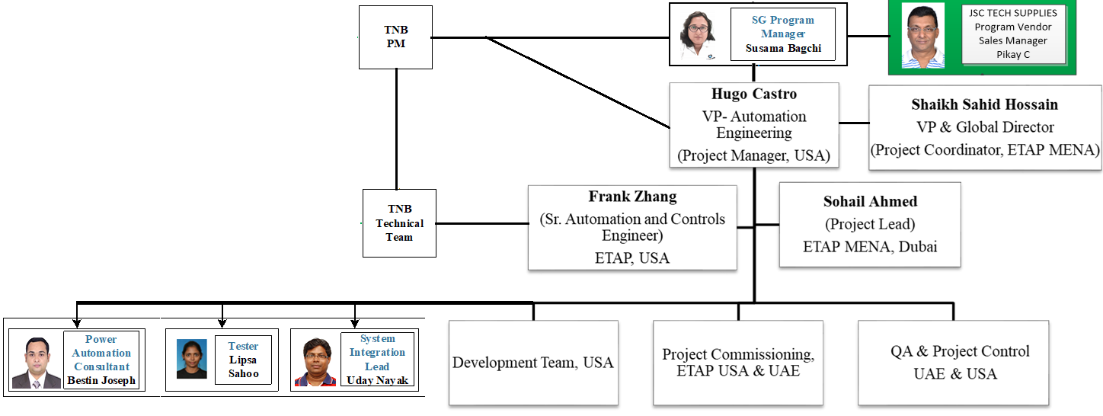

SG Team

# | Position | Name
1 | Project Vendor cum Project Coordinator | Pikay C
2 | Account Manager | Lim Siew Ju
3 | Program Manager | Susama Bagchi
4 | Power Automation Consultant | Bestin Joseph
5 | System Integration Lead | Udaya Nayak
6 | Tester | Lipsa Sahoo

ETAP Team

# | Position | Name
1 | VP-Automation Engineering, Project Manager, USA | Hugo Castro
2 | VP & Global Director, Project Coordinator, ETAP MENA, Dubai | Shaikh Sahid Hossain
3 | Sr. Automation and Control Engineer, ETAP USA | Frank Zhang
4 | Project Lead, ETAP MENA, Dubai | Sohail Ahmed

TNB PM and Technical Team

# | Position | Name
1 | Program Manager | Rosli Lajim

# | Name
1 | Dr. Looe Hui Mun
2 | Dr. Lo Chin Kim
3 | Azlan B. Abdul Rahim
4 | Lau Chu Chong
5 | Cheong Pui Leng
6 | Lim Khim Yan
7 | Che Nuzu Saniyyati

Scope of Work

JSC-SG and ETAP
For this tender, the proposed scope of works is as follow:
• On-Line Power Flow
• Volt-Var Optimization Engine. The engine will cover the loss calculation before and after the recommended changes using different objectives. The objectives are as below:
- Conservation Voltage Reduction – Peak Shaving
- Minimize Power Losses – Efficient VAR flow
- Optimize Voltage Profile
• On-line State Estimation
• System Integration, Quality Assurance and Testing

TNB
- All the hardware and listed items below:
No. | Item | Quantity
1 | ETAP RT Server | 1
2 | Ethernet Switch | 1
3 | OPC Software | 1
4 | Firewall and Antivirus | 1
5 | EWS/OWS | 2
6 | 21” Dual Monitor | 2

- Required information about the existing infrastructure to allow ETAP to collect data from the existing SCADA system and send control to the devices onsite
- Required data to model the ETAP VVO system

Hardware Requirement
Hardware will be provided by Client. The following specifications are recommended for this project:

ETAP Server Specification
Quantity # | Component | Description
2 | Processor | Intel® Xeon® E5-2620v3 (2.4GHz/6-core/15MB/85W) Processor
1 | System Memory | 64 GB Dual Rank x4 DDR4-2133 CAS 15-15-15 Registered Memory Kit
1 | Disk Drive | SATA DVD optical
8 | Hard Disk | 300GB 6G SAS 10K rpm SFF (2.5-inch)
4 | Network Connectivity | Ethernet 1 GB
1 | Raid Unit | RAID-10
1 | Operating System | MS Windows server 2012 R2 standard edition, 64 bit

ETAP Engineering and Operating Work Station Specification
Quantity # | Component | Description
2 | Processor | Intel® Xeon® E5-2620v3 (2.4GHz/6-core/15MB/85W) Processor
1 | System Memory | 32 GB Dual Rank x4 DDR4-2133 CAS 15-15-15 Registered Memory Kit
1 | Disk Drive | SATA DVD optical
1 | Hard Disk | 1 TB
4 | Network Connectivity | Ethernet 1 GB
1 | Raid Unit | RAID-10 recommended but not required.
1 | Operating System | MS Windows 10, 64 bit

System Overview

Table 1: ETAP Power System Monitoring & Simulation Applications
ETAP Applications | Purpose
Base | Power Applications Network Builder
 | SCADA Integrator
PSMS | Power System Monitoring and Simulation
 | ETAPS PM Server
 | SLE or DSE
Power Analysis | Unbalanced Load Flow
 | Volt-Var Optimization and Control
 | Optimal Capacitor Placement (OLD only)

ETAP Model
In order to perform system monitoring, control and power system analysis, ETAP needs to understand components ratings, normal operating conditions, typical load profiles & ratings, HVCB type & ratings, and other information pertaining to the ETAP VVO engine.

A master ETAP PSMS Model will be configured to reside in the ETAP Real-Time(RT) Server machine. In the RT server machine, ETAP will collect data from the existing SCADA System and then perform distribution load estimation. The results from distribution load estimation will then be used for VVO engine to run studies.

Single Line Diagrams
Pending. Need to update once modelling is finalized.

Data Import
The project will be modelled based on PSSE raw file and Excel file import.
- Import RAW Format
ETAP could create a one-line diagram with element connections and electrical properties by importing data from PSS®E project files. PSS®E project files supported by ETAP include the following formats:
- Power Flow Raw Data File (file extension *.raw)
- Sequence Data File (file extension *.seq)
- Dynamics Model Raw Data File (file extension *.dyr)

In order to import project files, the Power Flow Raw Data File (RAW) project file is required. The Sequence Data File (SEQ) project files and Dynamics Model Raw Data File (DYR) project files are optional when performing import to ETAP
- Import Excel file
User can import data from a MS Excel file into ETAP. From the ETAP File menu, point to DataX and then select Excel – Fixed Format.

System Architecture
The ETAP Real-Time server software will communicate with TNB existing SCADA system via OPC Client-Server OPC-DA protocol. Mapping information between the ETAP Real-Time Server and TNB SCADA system will be stored in the ETAP SCADA Integrator database known as “Tag Database”. All tags will be generated and/or maintained using the “SCADA Integrator” tool which stores the database in the MongoDB.

ETAP Real-Time server software will be installed on server machine while the ETAP application software will be installed on the workstation machines. For nomenclature purposes, the former is simply referred as “ETAP Real-Time Server” and the latter as “ETAP Console”. The ETAP consoles will communicate with the ETAP Real-Time server and get the necessary data for running different applications and analyses on demand.

All machines should be in the same domain in order to access data smoothly under proper security authorization.

Figure 1 shows the system architecture designed for this project. The following section will describe the details shown in that figure.
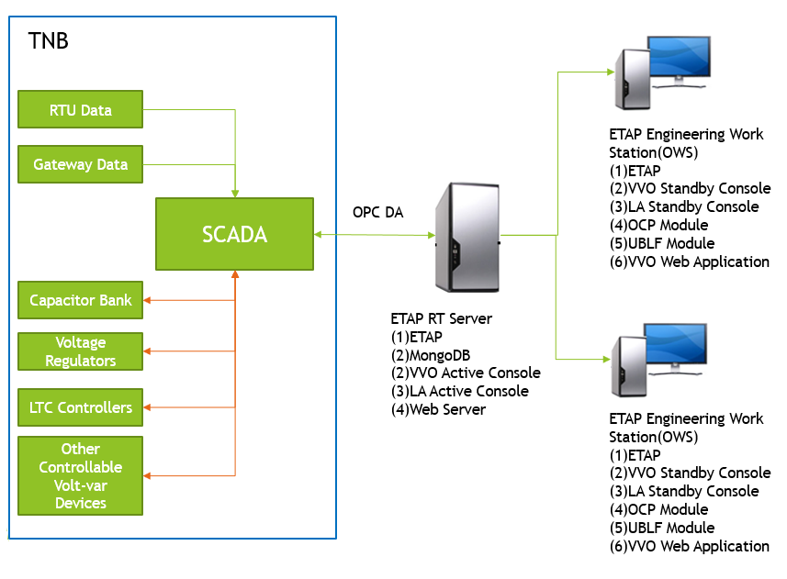
Figure 1: TNB ETAP VVO System Architecture

Components
ETAP will use the provided ethernet switch and cables to connect the RT Server, OWS and EWS in the same domain. ETAP RT Server will connect with TNB existing SCADA system via the ethernet switch as well.

ETAP Real-Time Server
ETAP Real-Time server communicates to TNB Scada system and processes the data to all ETAP consoles. There will be a total of one ETAP Real-Time server, in which MongoDB will be installed. The results from VVO engine will be stored in the mongo database.

ETAP Consoles
There will be two ETAP consoles. They will serve as Operating and Engineering Consoles (OEC) that will be running the ETAP application software. ETAP consoles communicate to the ETAP Real-Time server to collect available online data and results from the State and Load Estimation(SLE) and Distribution State and Load Estimation (DSE). The operator will be able to execute Advance Monitoring & Control and other power system analysis from these consoles.

Each console will contain a copy of the ETAP PSMS Model. The console is setup to select automatically the ETAP PSMS Model.

Engineers will use these consoles for run different studies as ULF, VVO and OCP.

Authorization
For access restrictions to the ETAP PSMS model, ETAP provides seven levels of access. For customization and operation of the TNB VVO system, only three access levels will be utilized. This section describes the different levels.

User Levels
ETAP Access Levels for PSMS:
- Level 0: Administrator – User and Password Manager
- Level 1: Project Editor – Data Manager
- Level 2: Operator – Monitoring and Control User

Each level has pre-defined privileges of accessibility.

Administrator
The administrator access level is only for user management. The administrator is responsible for establishing and maintaining all user access control. The administrator can add, modify, or delete user accounts, passwords, and access levels.

Project Editor
The project editor can modify the project database, create and audit field equipment software interfaces, and update the ETAP Real-Time server. The project editor can perform any function involved with the engineering, installation, or operation of ETAP Real-Time, including taking the system offline. Project editor is the highest access level for editing.

The project editor has access to all simulation and system settings.

Operator
The Operator can monitor & control the ETAP RT system. The operator cannot modify PSMS system settings such as modifying the mode or pin open/Close protective devices.

Graphical Representation

Primary Presentation
ETAP PSMS model is graphically represented by the one-line diagram. This one-line diagram is based on PSSE RAW format and Excel data provided by TNB.

The primary representation or “Sys Monitor” will display the individual Substations as a composite network, loads, and transmission \ distribution lines.

Figure 2 depicts a sample of the graphical representation of the ETAP PSMS model.

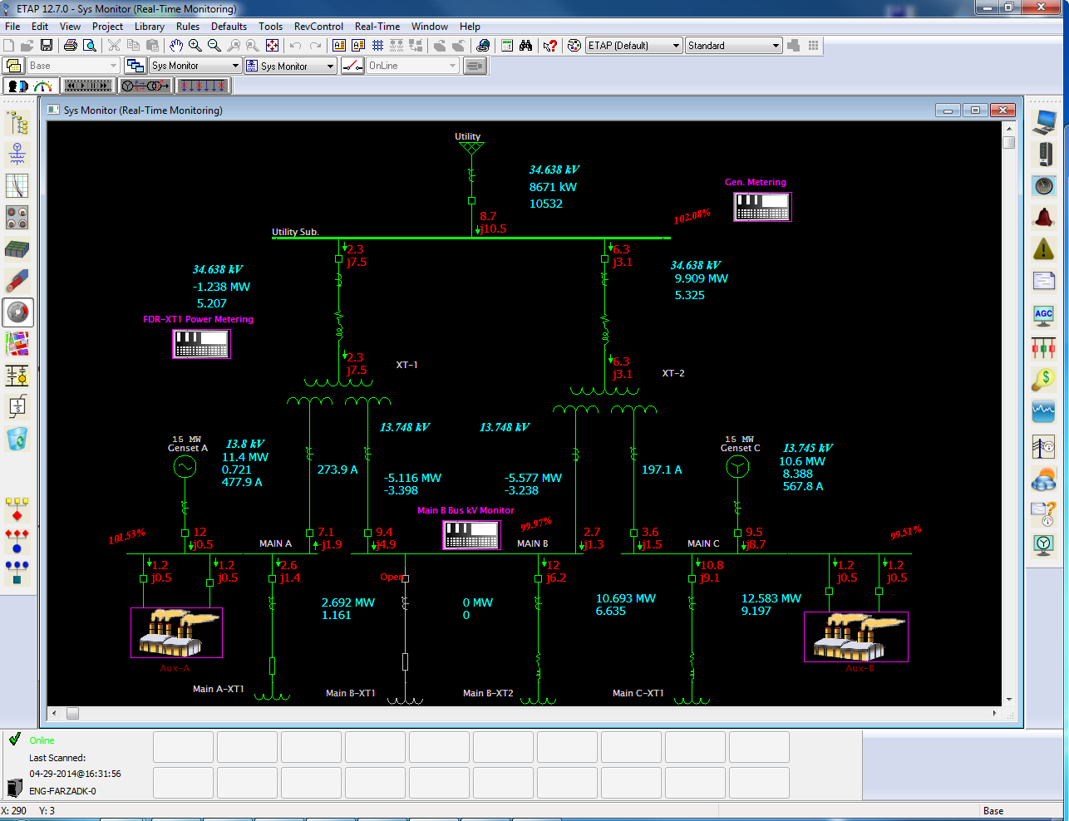
Figure 2: Sys Monitor Presentation

To access individual plants and substation diagrams, the dispatcher or operator has the following options:

- Double-click on the substation symbol.
- Open the “System Manager” view window and find the substation of interest by name under the Sys Monitor presentation, which is located at Multi-Dimensional Database→Presentations→One-Line Diagrams.
- Search by name by clicking on the search button on the project (top) toolbar.

Sys Simulation presentation
This presentation will be used to perform system studies using real-time data.

Composite network presentations
To be detailed when the ETAP model is created and cleaned.

Software Overview
The following software applications are provided with the system for PSMS applications:

ETAP
ETAP will be installed in each server machine and work station. An ETAP License Manager will also be installed in the RT Server machine. The PM Server inside ETAP will be provided to communicate with existing SCADA System, and the communication will be via OPC-DA protocol. The latest version will be provided by the time of FAT.

ETAP Applications

Overview
The following ETAP software will be utilized for this project.

Name: ETAP Real-Time Enterprise Server and Console Software
Version: 2000 or above
Supplier: Operation Technology, Inc. dbo ETAP

Applications
ETAP will provide electrical power System Monitoring and Simulation applications that will enable operators to monitor the distribution system and help Engineers to perform power system analysis and model update. The applications included for this project are:

ETAP Applications | Purpose
Base | Power Applications Network Builder
 | SCADA Integrator
PSMS | Power System Monitoring and Simulation
 | ETAPS PM Server
 | SLE or DSE
Power Analysis | Unbalanced Load Flow
 | Volt-Var Optimization and Control
 | Optimal Capacitor Placement
Table 2. ETAP Power System Monitoring & Simulation Applications

These applications will be provided in order to implement VVO system with real time data in TNB’s environment.

Exceptions to Specifications
Not applicable

Base Mode
The Base mode in ETAP is designed for the creation and management of the ETAP PSMS Model database. This mode provides an easy to use, fully Graphical User Interface (GUI) for constructing one-line diagrams and database for the ETAP PSMS model. The graphical one-line diagram and database serves as one common platform for all PSMS applications.

Basic Design Premises
The creation of the database is transparent to the users. The user can graphically construct the PSMS by connecting buses, branches, motors, generators, and protective devices in any order from the One-Line Diagram Edit toolbar. You can connect elements to buses graphically (by dragging lines from the device element) or by using the Info page of the Device Property editor (double-click on the element and its property editor will open). In addition, the operator can graphically add, delete, relocate, connect elements, zoom in or out, display grid off or on, change element size, change element orientation, change symbols, change equipment / device color, create personalized viewing themes, hide or show protective devices, enter properties, set operating status, etc.

As the user builds the graphical interface, ETAP is generating the database without any intervention from the user.

System Overview
This section describes the overall capabilities of the Base mode in ETAP. This mode is equivalent to the Power Applications Network Builder.
From the Base mode, the user has access to:
- Data Editing
- Graphics Editing

Data Editing
ETAP keeps track of the detailed data for each PSMS component. Data editors are designed to speed up the data entry process. The data entry can be accessed by double-clicking on the component on the one-line diagram Figure 3 displays a typical data editor for a 2-winding transformer.

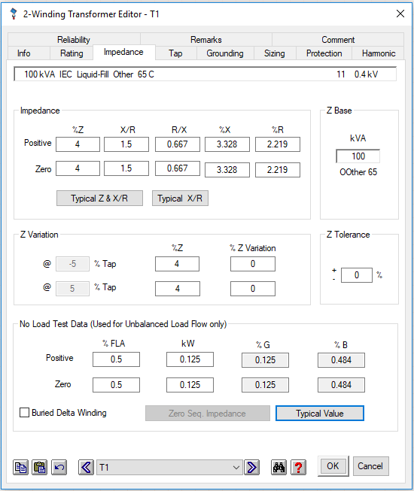
Figure 3: Winding Transformer Editor

Using these editors the user can assign the engineering properties of the element, such as its ratings, settings, loading, connection, etc. All editors in ETAP are designed with intelligence so that electrical relationships between fields are followed. This speeds up the process of entering information requiring the minimum data. The editors have been structured in the most logical manner for entering data for different types of applications. Marked changed data, undo, search, and navigate are some of the standard features in each editor.

Graphics Editing
In this section some of the most common functions of the graphical user interface for the one-line diagram are explained. The detailed instructions provided here will assist you in creating and editing your one-line diagram presentation.

Mouse and Keyboard Functions
Function | Description
Click | Placing the mouse cursor on an object or button, and then click the left mouse button. Click is used to select an element in the one-line diagram, add elements from the toolbars, etc.
Right-Click | Placing the mouse cursor on the object, and then click the right mouse button. For example, right-clicking on an element in the one-line diagram brings up a menu.
Double-Click | Placing the mouse cursor on an object or button, and then click the left mouse button twice rapidly. For example, double-clicking on an element in a one-line diagram brings up the property editor for that element. For composite networks and motors, double-clicking brings up the nested one-line diagram for that composite element.
<Ctrl> + Click | Placing the mouse cursor on the object, then, while pressing the <Ctrl> key down, click the left mouse button. Use <Ctrl> + click to select or deselect one-line diagram elements.
Drag | Placing the mouse cursor on an element, click and hold the left button down, drag the mouse to the required position while keeping the left button down, then release the left button to Placing the element.
Selecting | Make sure the mouse cursor is not on any element; click and hold the left button down. Drag the mouse to the required position while keeping the left button down, and then release the left button. You will see a rectangle marked with dotted lines indicating the area that you have selected. This is used for selecting a group of elements.
Drag and Drop | Drag and Drop is the ability to copy elements using the mouse within an ETAP project and, in one mouse motion, paste the elements onto an accepting location within ETAP. Drag and Drop is used in ETAP only for copying elements (but not for cutting or purging elements)

Adding Components
To add an element to the one-line diagram model, click on any of the device element buttons on the Edit toolbar. Notice how the cursor changes its shape to that of the element’s icon. Now you can drag and drop that element in any position on the one-line diagram by clicking the mouse. After dropping the element, the cursor returns to its original arrow shape.

Double-click on an element on the Edit toolbar to add multiple copies of the same element to the one-line diagram. As the mouse is clicked, a copy of the selected element is placed at each location.

Presentation Functions
The following functions are available for the graphics. The system can be online or offline.

Function | description
Zoom In | Magnify the one-line diagram.
Zoom Out | Reduce the one-line diagram.
Back / Forward | Undo zoom level for the one-line diagram. Forward Redo the zoom level for the one-line diagram.
Zoom to Fit Page | Resize the one-line diagram to fit the window.
Show Grid Lines | Display the grid lines on the one-line diagram.

System Continuity Check
Continuity check is a function that continuously checks if any component is energized or de-energized in the network. With this function you can graphically see when a component is de-energized (there is path to source) or if a breaker or any switching device is open or closed. This function is optionally applied in any of the simulation models and is always applied on online mode.

Configure SCADA Integrator
SCADA Integrator is the application which holds all tags mapping used for online monitoring. In order to bring system online properly, user will need to do the following:
- Add component to SCADA Integrator
Selecting required components in ETAP OLV, and then select Real-Time-> SCADA Integrator ->Add ETAP Components to SCADA Integrator.
- Create device model
For each type of components, it requires at least one device model. Right click on Device Model section to create device models. Each device model is a modelling template for each type of component
- Specify the driver to use
In Drivers section, user needs to specify the 3rd party driver if required.
- Associate device model to component
Navigate to ETAP components section, associate each component with desired device model and client.
- Perform tag mapping
In Tags section, map tags to desired address based on requirement.

SLE - State and Load Estimator
The SLE uses the state-of-the-art interior point optimization technique with the logarithm barrier function for minimizing the residual between measurements and estimated values. It utilizes the ETAP PSMS Model to achieve the ultimate accuracy and capability in solving power system state estimation under feasible conditions.

Data Requirements
SLE uses different types of measurements, that is, Real Measurements, Pseudo Measurements, and Pinned Measurements.

Real Measurements
These are the actual measurements from meters in the system and switching devices.

Pseudo Measurements
These are the loading of individual loads. The loading of individual loads is calculated using the percentage loading of the Active Loading Category that is selected in the ETAP Real-Time server. It is calculated using the following relation:

Loading MW = (% Loading) x (Rated MW)
Loading MVar = (% Loading) x (Rated MVar)

The percentage loading is often based on statistical data and Varies from time to time, for example the percentage loading in the summer time is different from the percentage loading in the winter time.

In addition, the system is capable of utilizing load profiles. The load profiles can be stored in a library based on industry type. The profiles then can be loaded into each of the loads modeled. ETAP calculates the actual load based on size and type of load as follows:

Loading MW = (Rated MW) x (% Load Profile)
Loading MVar = (% Loading) x (% Load Profile)

Pinned Measurements
The meters and switching devices in ETAP Real-Time provide the option to pin (override) the online scanned data. The pinned value refers to an override value set by the operator in lieu of the measured value. This feature is useful in case of a faulty meter, communication failure, etc. The pinned value may be based on observed, historical, or forecasted data.

Weight Factor
Weight factors are available in ETAP Real-Time to adjust the importance associated with different measurements.

The weight factor for actual measurements depends on the specified Standard Deviation. The Standard Deviation associated with actual measurements is specified on the online tab of the Meter editors. The weight factor for actual measurements is inversely proportional to the square of the Standard Deviation.

For example in Figure 4 the weight factors for the measured voltage, current, kW, kVar, power factor, and frequency is the same and is equal to 100 (= 1/0.01).

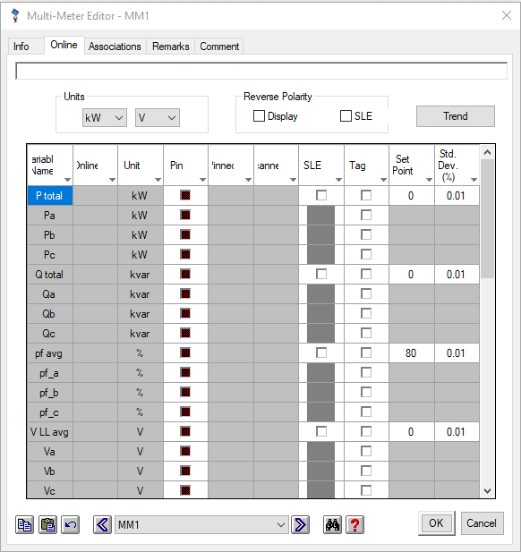
Figure 4: Multi-Meter Editor

The weight factor for pseudo measurements is specified in the ETAPS.INI file. It has a default value of 0.0001 and is the same for all pseudo measurements. This weight factor Varies from system to system and has to be tuned. The tuning is done based on the difference between measured and estimated values displayed on the one-line diagram.

Location and Number of Measurements
ETAP Real-Time provides an efficient solution by determining the power flow in each branch and load with the help of the network model, pseudo measurements, and system configuration. SLE estimates flows into loads based on their loading (as determined by the Loading Category), when metered data is not available. It distributes the first available upstream measured power to the downstream loads based on their percentage loading.

Although the SLE in ETAP Real-Time is capable of providing accurate results with few measurements, the accuracy of results increases if the measurements are sufficient in number and are performed at optimum location. It is important that the meters in the system are placed at optimum locations to provide the minimum data required to perform state estimation.

SLE Convergence
The accuracy and convergence of SLE depend greatly on the accuracy of the ETAP PSMS Model and the locations of metering. Initial inspection indicates that metering may not be a factor as simplifications of the model have been performed to minimize the impact.

The main concern is the accuracy of the model since much of the data will be based on typical information and assumptions. Tuning of this information will be required when the system is placed in operation for improving SLE convergence and\or accuracy.

Unbalanced Load Flow
Many applications of distribution systems require a robust and efficient power flow solution method. A power flow solution method must be able to model the special features of distribution systems in sufficient detail. Distribution systems have a relatively unbalanced nature, which results from a mixture of 3-phase, 2-phase, and single-phase network components, including unbalanced loads and shunts. Therefore, an unbalanced load flow analysis has become the preferred solution.
The ETAP Unbalanced Load Flow Analysis program calculates the bus voltages, branch power factors, currents, and power flows for individual phases throughout the electric power system. The module allows for swing, voltage regulated, and unregulated power sources with multiple utility and generator connections. It handles both radial and loop systems. A powerful current injection method is provided in order to achieve the best calculation efficiency.

Unbalanced Load Flow Toolbar
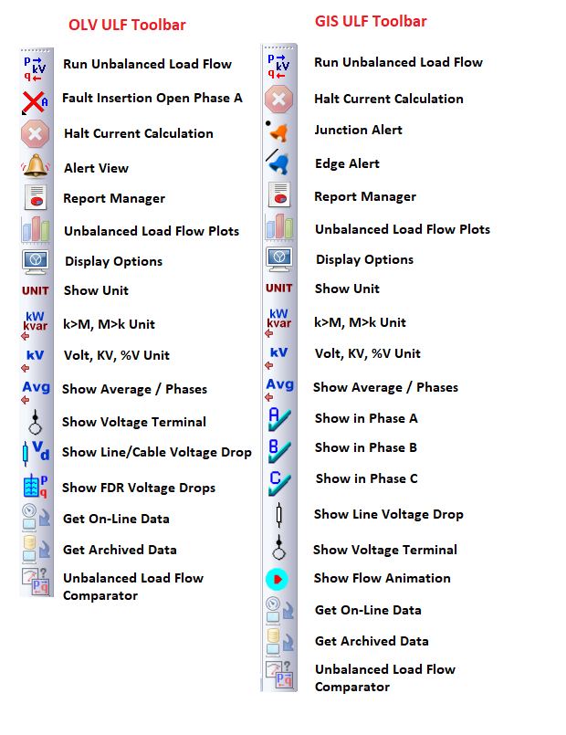
Run Unbalanced Load Flow Studies
Running an unbalanced load flow study is a simple, two-step process:
- Select a study case from the Study Case editor.
- Click the Run Unbalanced Load Flow Study button to perform an unbalanced load flow study.
A dialog box appears. Specify the output report name if the output file name is set to Prompt. The study results appear on the one-line diagram and in the output report.
Run Open Phase Fault Studies
Running an Unbalanced Load Flow Study is a simple, three-step process:
- Select a Study Case from the Study Case Editor.
- Select an Open Phase by left-clicking on the button and navigating through A, B, C, AB, BC, CA phases.
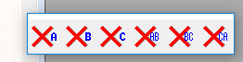
- Place the fault on a connector of any three-phase branch by left-clicking the button and left-clicking on the connector.
If the three-phase branch is a transmission line, the line will not be in any mutual coupling group with other transmission lines.
Unbalanced Load Flow Display Options
The results from unbalanced load flow studies are displayed on the one-line diagram. To edit how these results look, click the Unbalanced Load Flow Display Options button.
Alert View
After performing an unbalanced load flow study, you can click this button to open the Alert View, which lists all equipment with critical and marginal violations based on the settings in the study case.
Junction Alert
Show/hide the over or under voltage color on the GIS junction if there is any alert.
Edge Alert
Show/hide the overstressed color on the GIS edge if there is any stressed line/ cable.
Unbalanced Load Flow Report Manager
Unbalanced Load Flow Output Reports are provided in the form of Crystal Reports report. The Report Manager provides four pages (Complete, Input, Result, and Summary) for viewing the different parts of the output report from Crystal Reports. Available file types for Crystal Reports are displayed in each page of the Report Manager for unbalanced load flow studies.

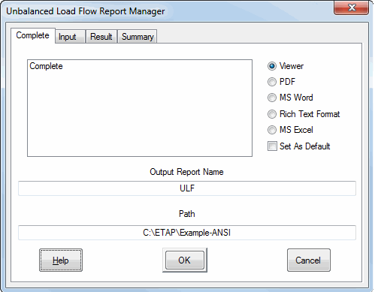

Choosing any format in the Report Manager activates Crystal Reports. You can open the whole Unbalanced Load Flow Output Report or only a part of it, depending on the format selection. You can view the report in the Crystal Reports viewer, or save the report in PDF, MS Word, Rich Text Format, or Excel format. If you prefer this to be the default format for reports, click the Set As Default checkbox.

The following table explains the format names and their corresponding Output Reports.

This format… | Provides this information…
Adjustments | Tolerance and temperature correction adjustments
Alert-Complete | Complete report of system alerts
Alert-Critical | Summary of critical alerts only
Alert-Marginal | Summary of marginal alerts only
Branch | Branch input data
Branch Loading | Branch loading results
Bus | Bus input data
Bus Loading | Overloaded bus information
Cable | Cable input data
Complete | Complete output report, including all input and output
Cover | Title page of the output report
Equipment Cable | Equipment cable input data
Impedance | Detailed information about impedance elements in the system
Losses | Branch loss results
NO Protective Devices Displays | Normally open protective devices
Reactor | Reactor input data
Summary | Summary of the load flow calculation
Transformer | Transformer input data
Unbalanced LF Report | Unbalanced load flow calculation results

You can view Output Reports by clicking the Report Manager button on the Study Case toolbar. The List Output Report window lists all the output files in the selected project directory for unbalanced load flow calculations. To view any of the listed Output Reports, select the Output Report name and click the List Output Report button.

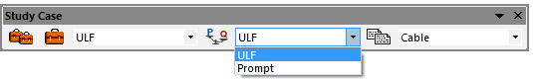
Halt Current Calculation
The Halt Current Calculation button is normally grayed-out. When an unbalanced power flow calculation has been initiated, this button becomes enabled and shows a red stop sign. Clicking on this button will terminate the calculation.
Show FDR Voltage Drops
Show/Hide FDR voltage drops.
Show Line/Cable Voltage Drop
Show/Hide voltage drop on the line or cable
Show Flow Animation
Show/Hide power flow animation
Get On-line Data
When Real-Time is installed and the Sys Monitor presentation is on-line, you can bring real-time data into your offline presentation and run an unbalanced load flow calculation by clicking the Run Unbalanced Load Flow button. The Operating Loads, Bus Voltages, and Study Case Editor will be updated with the on-line data.
Get Archived Data
When ETAPS Playback is installed and any presentation is in Playback mode, you can bring this data into your presentation and run an unbalanced load flow calculation by clicking the Run Unbalanced Load Flow button. The Operating Loads, Bus Voltages, and Study Case Editor will be updated with the playback data.
Unbalanced Load Flow Comparator
When ETAP Real-Time is set up after you run a Load Flow Study with on-line data, you can click this button to bring up the Load Flow Comparator view. It lists comparisons of all system operating values between ETAP Real-Time output and Load Flow calculations. Currently not available on the GIS view.

Unbalanced Load Flow Study Case
The Unbalanced Load Flow Study Case Editor contains solution control Variables, loading conditions, and a Variety of options for Output Reports. ETAP allows you to create and save an unlimited number of Study Cases. Unbalanced load flow calculations are conducted and reported using the settings of the Study Case selected in the toolbar. You can switch between Study Cases without resetting the Study Case options each time. This feature is designed to organize your study efforts and save you time.
As a part of the multi-dimensional database concept of ETAP, Study Cases can be used for any combination of the three major system toolbar components (that is, for any configuration status, one-line diagram presentation, or base/revision data).
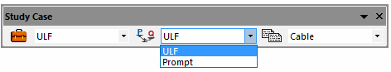
When you are in Unbalanced Load Flow Analysis mode, you can access the Unbalanced Load Flow Study Case Editor by clicking on the Edit Study Case button from the Study Case toolbar when in Unbalanced Load Flow Analysis mode. You can also access this editor from the System Manager by clicking on the unbalanced load flow project in the Study Case folder.
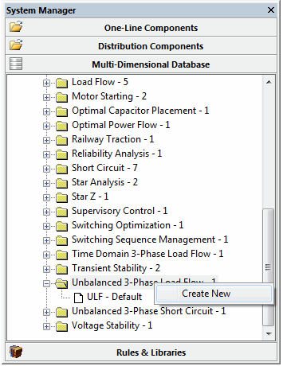
Info Page
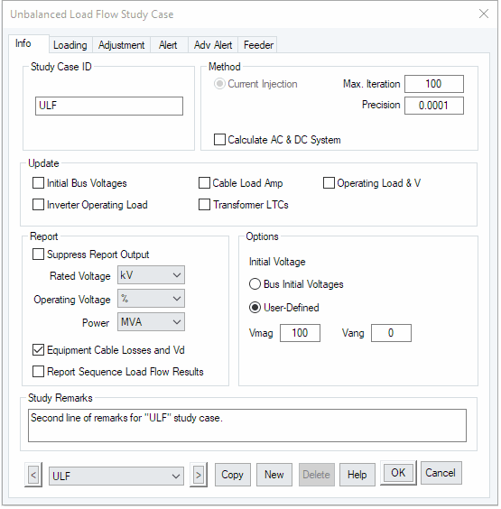
Study Case ID
In the Study Case ID group, you can rename a study case by deleting the old ID and entering the new ID. The study case ID can be up to 25 alphanumeric characters. Use the arrow buttons at the bottom of the editor to go from one study case to another.
Method
The currently available method is the Newton-Raphson Current Injection Method.
Max. Iteration
Enter the maximum number of iterations. If the solution has not converged before the specified number of iterations, the module will stop and inform you. The recommended and default values are 99.
Precision
Enter the value for the solution precision (used to check for convergence). This value determines how precise you want the final solution to be. The precision is applied to check the difference between the bus voltages after each iteration. If the difference between the iterations is less than or equal to the value entered for precision, the desired accuracy is achieved.
If the solution converges but the mismatch values are high, reduce the value of the precision to make your results more precise and run the module again.
Note: You may need to increase the number of iterations. A smaller precision value will result in a lower mismatch (higher accuracy), as well as a longer run time. The default value of 0.0001 pu volts is recommended.
Calculate AC & DC System
Check this checkbox to perform calculation for AC and DC systems simultaneously. When this checkbox is unchecked, the simulation will only consider AC part of the system.
Update
In the Update group, you can decide to update the initial conditions of the buses and/or set the transformer taps to the calculated value of load tap changers (LTCs). The selected options will be updated after the subsequent unbalanced load flow run.
Initial Bus Voltages
Select this option to update the values of the bus voltage magnitudes with the result of the load flow run. Bus voltage update will result in a faster convergence of the subsequent load flow solutions, since the initial bus voltages will be closer to the final values.
Inverter Operating Load
In an AC load flow study, an inverter is represented as a constant voltage source. When this option is checked, the load provided by the inverter will be updated to the inverter element, which can be used later as DC load of the inverter in a DC load flow study.
Operating Load & V
This option is available if your ETAP installation has the online feature. When you select this option, the calculation results will be updated to sources, loads, and buses, so that they can be utilized as input for later studies. These values are also displayed in element editors. If your ETAP installation does not include the online feature, you can only see the operating P, Q, and V in element editors, and they cannot be used in a later study.
Transformer LTCs
Select this option to update the transformer taps to reflect the result of the load tap changer (LTC) settings (that is, transformer taps will be set to values determined from the load flow solution for LTCs). Use this feature when you want to consider the impedance of the LTC taps for short circuit calculations.
Cable Load Amp
Select this option to transfer cable load current data from the previously run unbalanced load flow study. The data is transferred to the Operating Load Current in the Cable editor for each cable associated with the unbalanced load flow study.
Report
Suppress Report Output
Check this box to suppress the output report. Study reports will not be generated.
Rated Voltage In
Bus nominal voltages seen in the output report can be printed in V or kV. Select your preference from the drop down list.
Bus Operating Voltage In
Calculated bus voltages seen in the output report can be printed in V, kV or in percent of the bus nominal voltages. Select your preference from the drop down list.
Power In
Calculated power flows, loadings and generations seen in the output report can be printed in MVA or kVA. Select your preference from the drop down list. For graphical display of the power flows see Load Flow Display Options.
Equipment Cable Losses and Vd
Select this option to report losses and voltage drops associated with equipment cables in the output report.
Report Sequence Load Flow Results
Select this option to report load flow results in sequence domains for 3-phase elements.
Initial Voltage Condition
Initial conditions for all bus voltages and angles can be specified in this group for unbalanced load flow calculation purposes.
Bus Initial Voltages
Select this option to use bus voltages and angles as entered in the Info page of the bus editors. You can simulate unbalanced load flow studies with different initial conditions for bus voltage using this option.
User-Defined Fixed Value
Select this option to simulate unbalanced load flow studies using a fixed bus voltage and angle for all buses. When you select the fixed initial condition option, you must enter the initial voltage value as the percent of the bus nominal voltage. The default values are 100% for bus voltage magnitude and zero degree for bus voltage angle.
Determination of Initial Bus Voltage Angle
The ETAP Unbalanced Load Flow Analysis module calculates the bus voltage angle based on transformer phase-shift and compares the calculated value against the initial bus voltage angle from the user selected option. If the difference between the two values is larger than the specified MaxIniAngDiff, ETAP uses the calculated values as the initial bus voltage angle, where MaxIniAngDiff is an ETAP.INI file entry that is defaulted at 10.
When the operating load is specified as the system load, the operating voltage angles are used as the initial value. In this case, the operating voltage angle is compared against the calculated bus voltage angle. If the difference is less than MaxIniAngDiff, the operating voltage angle is used; otherwise, the calculated value is used in the unbalanced load flow calculation.
Study Remarks
You can enter up to 120 alphanumeric characters in this field. Information entered here will be printed on the second line of every output page header line. These remarks can provide specific information for each study case.
Note: The first line of the header information is global for all study cases and is entered in the Project Information editor.
Loading Page
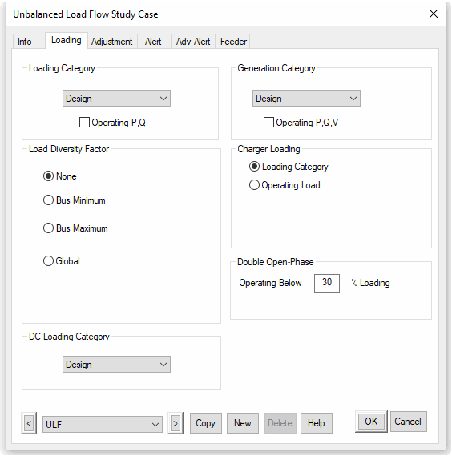
Loading Category
Select one of the ten loading categories in the Loading Category group for the current unbalanced load flow study. ETAP uses the percent loading of individual motors and other loads as specified in the category you select.
Note: You can assign loading to each one of the ten categories from the Nameplate page of the Induction Machine editor, Synchronous Motor editor, and the Loading or Rating page of other load component editors.
Operating P, Q
This option is available if your ETAP installation has the online feature. When you select this box, the operating loads updated from online data or a previous unbalanced load flow study will be utilized in the unbalanced load flow study.
Generation Category
Select one of the ten generation categories in the Generation Category group for the current unbalanced load flow study. When you select a category, ETAP uses the generator controls for that category, as specified on the Rating page of the Generator editor. The generator controls will be different depending on the mode in which the generator is operating. The mode of generation is selected on the Info page of the Generator editor. The table below shows the generation controls with respect to the mode of generation.
Mode | Generation Category Control
Swing | %V and Angle
Voltage Control | %V and MW
MVAR Control | MW and MVAR
PF Control | MW and PF

Operating P, Q, V
This option is available if your ETAP installation has the online feature. When you select this box, the generator operating values updated from online data or a previous load flow study will be utilized in the unbalanced load flow study.
Load Diversity Factor
The options in this group allow you to specify load diversity factors to be applied on the loading category’s load. When you select the Operating Load option, no diversity factor is considered.
None
Select None to use the percent loading of each load as entered for the selected Loading Category
Bus Minimum
When you select the Minimum Bus Loading option, all motors and other loads directly connected to each bus will be multiplied by the bus minimum diversity factor. Using this option, you can simulate load flow studies with each bus having a different minimum diversity factor.
The minimum bus loading study option may be used to see the effect of transformer taps and capacitors (if any) on the system voltages under a minimum (light) loading condition.
Bus Maximum
When you select the Maximum Loading option, all motors and other loads directly connected to each bus will be multiplied by the bus maximum diversity factor. Using this option, you can simulate load flow studies with each bus having a different maximum diversity factor.
This study option is helpful when the future loading of the electrical system has to be considered and each bus may be loaded at a different maximum value.
Global
Enter the global diversity factors for all constant kVA, constant Z, generic, and constant I loads. When you select this option, ETAP will globally multiply all motors and static loads of the selected Loading Category with the entered values for the motor and static load diversity factors. For information about load-modeling concepts used in the module, see section Calculation Method.
Note: A motor load-multiplying factor of 125% implies that the motor loads of all buses are increased by 25% above their nominal values. This value can be smaller or greater than 100%.
Const. kVA
Constant kVA loads include induction motors, synchronous motors, and conventional lumped loads with % motor load, UPS, and chargers.
Const. Z
Constant impedance loads include static loads, capacitors, harmonic filters, MOVs, and conventional lumped loads with % static load.
Const. I
Constant current loads include lumped loads operating in unbalanced mode.
Generic
Generic loads include lumped loads operating in either exponential, polynomial, or comprehensive mode.
Charger Loading
For chargers, you can select the Loading Category or the Operating Load if the “Calculate AC & DC System” checkbox is unchecked at Info page of the study case.
If the “Calculate AC & DC checkbox is checked, the charger loading will based on flow results at the DC side of the charger. In this case, you may select Constant Current mode or Uniform mode for charger loading. In AC-DC unified load flow, 3 phase charger will be modeled as a delta connected load. When using Uniform model, the charger loading between AB, BC, CA will be the same. When using Constant Current model, the charger loading between AB, BC, CA will be proportional to respective charger L-L voltages.
DC Loading Category
Select one of the ten Loading Categories in the Loading Category group for DC part of the Unbalanced Load Flow Study. ETAP uses the percent loading of DC loads as specified in the category you select.
Double Open-Phase
Enter the threshold for loads to consider operating instead of lock-rotor impedances when below this threshold.
Adjustment Page
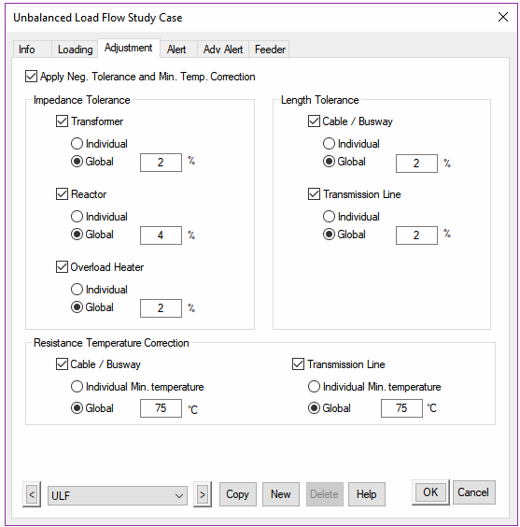
The Impedance Tolerance, Length Tolerance, and Resistance Temperature Correction groups on the Adjustment page allow you to consider tolerance adjustments to length, equipment resistance, and impedance. Each tolerance adjustment can be applied based on the individual equipment percent tolerance setting or based on a globally specified percent value.
Tolerances are typically applied to electrical calculations especially in cases where the actual equipment data is suspect, manufacturer datasheet reflects tolerances or it is a new electrical system design.
Apply Neg. Tolerance and Min. Temp. Correction
When tolerances are applied to the load flow calculation, they are typically considered as positive tolerance for impedances & length and maximum temperature value from resistance temperature correction. This is done such that the load flow calculations yield higher voltage drops & losses; making the results more conservative. By applying this checkbox, load flow calculations shall utilize negative tolerance and minimum temperature correction making the results less conservative.
Impedance Tolerance
Transformer
The net effect of the transformer impedance adjustment in unbalanced load flow calculations is to increase the impedance by the specified percent tolerance value. For example, if the transformer impedance is 12% and the tolerance is 10%, the adjusted impedance used in the unbalanced load flow calculation will be 13.2%, resulting in higher losses.
The impedance adjustment can be applied to individual transformers by selecting the Individual option. This option uses the tolerance percent value specified on the Rating page of the Transformer editor. To make a global transformer impedance adjustment, select the Global option and type a global tolerance other than 0% in the displayed text box. The global impedance adjustment overrides any individual transformer tolerance value.
Reactor
This adjustment is applied to the reactor impedance. The Unbalanced Load Flow Analysis module increases the reactor impedance by the specified percent tolerance, resulting in a larger impedance and consequently a larger voltage drop. For example, if the impedance of the reactor is 0.1 Ohm and its tolerance is 5%, then the adjusted reactor impedance used in the unbalanced load flow calculation is 0.105 Ohm.
The impedance adjustment can be applied to individual reactors by selecting the Individual option. This option uses the tolerance percent value specified on the Rating page of the Reactor editor. To make a global reactor impedance adjustment, select the Global option and type a global tolerance other than 0% in the displayed text box. The global impedance adjustment overrides any individual reactor tolerance value.
Overload Heater Resistance
This adjustment is applied to the overload heater (OH) resistance. The Unbalanced Load Flow Analysis module increases the OH resistance by the specified percent tolerance resulting in a larger resistance and consequently a larger voltage drop. For example, if the resistance of the OH is 0.1 Ohm and its tolerance is 5%, then the adjusted OH resistance used in the load flow calculation is 0.105 Ohm.
The resistance adjustment can be applied to individual overload heaters by selecting the Individual option. This option uses the tolerance percent value specified on the Rating page of the Overload Heaters editor. To make a global overload heater resistance adjustment, select the Global option and type a global tolerance other than 0% in the displayed text box. The global resistance adjustment overrides any individual overload heater tolerance value.
Note: The adjustments only apply if the Cable/OL Heater option is selected for MV and/or LV motors.
Length Tolerance
Cable
This adjustment is applied to the cable length. The Unbalanced Load Flow Analysis module increases the cable length by the specified percent tolerance resulting in larger impedance and consequently a larger voltage drop. For example, if the length of the cable is 200 ft. and the tolerance is 5%, then the adjusted cable length used in the unbalanced load flow calculation is 210 ft.
The length adjustment can be applied to individual cables by selecting the Individual option. This option uses the tolerance percent value specified on the Info page of the Cable editor. To make a global cable length adjustment, select the Global option and type a global tolerance other than 0% in the displayed text box. The Global Length Adjustment overrides any individual cable tolerance value.
Transmission Line
This adjustment is applied to the transmission line length. The Unbalanced Load Flow Analysis module increases the transmission line length by the specified percent tolerance resulting in larger impedance and consequently a larger voltage drop. For example, if the length of the transmission line is 2 miles and the tolerance is 2.5%, then the adjusted transmission line length used in the unbalanced load flow calculation is 2.05 miles.
The length adjustment can be applied to individual transmission lines by selecting the Individual option. This option uses the tolerance percent value specified on the Info page of the Transmission Line editor. To make a global transmission line length adjustment, select the Global option and type a global tolerance other than 0% in the displayed text box. The Global Length Adjustment overrides any individual transmission line tolerance value.
Resistance Temperature Correction
This group allows you to consider resistance correction based on the maximum operating temperature for cable and transmission line conductors. Each temperature resistance correction can be applied based on the individual cable/line maximum temperature setting or based on a globally specified value.
Cable
This adjustment is applied to the cable conductor resistance. The Unbalanced Load Flow Analysis module adjusts the conductor resistance based on the maximum operating temperature. If the maximum operating temperature is greater than the rated base temperature of the conductor, then its resistance is increased.
The temperature correction can be applied to individual cables by selecting the Individual option. This option uses the maximum operating temperature value specified in the Cable editor. To make a global temperature correction, select the Global option and type a global maximum temperature value in the displayed text box. The global temperature correction value overrides any individual Cable Impedance page maximum temperature. For more information, see the Cable Editor Impedance Page section in Chapter AC-Editors.
Transmission Line
This adjustment is applied to the transmission line conductor resistance. The Unbalanced Load Flow Analysis module adjusts the conductor resistance based on the maximum operating temperature. If the maximum operating temperature is greater than the rated base temperature of the conductor, then the resistance is increased.
The temperature correction can be applied to individual lines by selecting the Individual option. This option uses the maximum operating temperature value specified on the Impedance page of the Transmission Line editor. To make a global temperature correction, select the Global option and type a global maximum temperature value in the displayed text box. The global temperature correction value overrides any individual Transmission Line Impedance page maximum temperature.
Alert Page
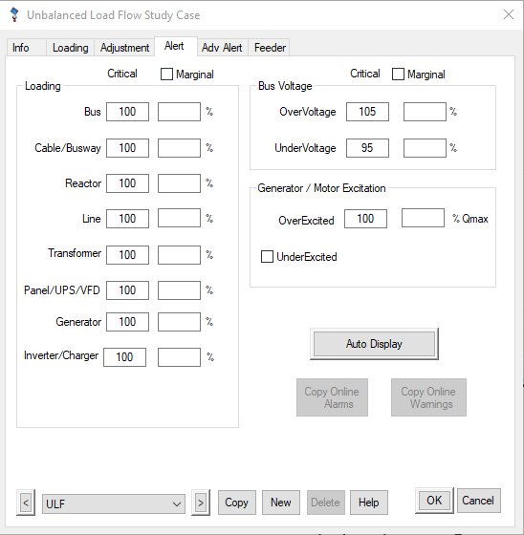
The Alert page in the Unbalanced Load Flow Study Case editor is used to setup primary simulation alerts that notify users about an abnormal loading condition based on allowable percent values and system topology. The functional capability of the Simulation Alert System is to generate alerts when there is an overload in protective devices, buses, transformers, cables, lines, panels, reactors, generators, or the power grid. The alerts are reported either graphically in the one-line diagram display or in the Alert View window.
Critical and Marginal Alerts
Simulation alerts generated after an Unbalanced Load Flow Study are either critical or marginal. Critical and marginal alerts use different percent value conditions to determine if an alert should be generated. If the condition for a critical alert is met, then an alert will be generated in the Alert View window and the overloaded element will turn red in the one-line diagram. The same is true for marginal alerts, except that the overloaded component will be magenta instead of red. Also, you must select the Marginal Limit option if you want marginal alerts displayed. If a device alert qualifies as both a critical and a marginal alert, only a critical alert is displayed.
Note: For ETAP to generate alerts for an element type, both the element rating and the percent value entered on the Alert page must be non-zero. The element ratings for alert checking are given in the following sections.
Loading
This group of options allows you to enter the condition percent values of the monitored parameters used to determine if an alert should be reported based on loading conditions determined by an unbalanced load flow calculation. Unbalanced load flow loading alerts generate overload alerts.
Bus
The Unbalanced Load Flow Analysis module will generate a bus loading alert if the critical or marginal percent limit of rated continuous current in the bus is exceeded. The rated continuous current in the bus is specified on the Rating page of the Bus editor.
Cable
The Unbalanced Load Flow Analysis module will generate a cable alert if the critical or marginal percent limit of allowable ampacity in the cable is exceeded. The allowable ampacity of the cable is specified on the Ampacity page of the Cable editor.
Reactor
The Unbalanced Load Flow Analysis module will generate a reactor alert if the critical or marginal percent limit of rated current in the reactor is exceeded. The rated current in the reactor is specified on the Rating page of the Reactor editor.
Line
The Unbalanced Load Flow Analysis module will generate a line alert if the critical or marginal percent limit of allowable ampacity in the transmission line is exceeded. The allowable ampacity of the transmission line is specified on the Ampacity page of the Transmission Line editor.
Transformer
The Unbalanced Load Flow Analysis module will generate a transformer alert if the critical or marginal percent limit of maximum MVA of the transformer is exceeded. The maximum MVA of the transformer is specified on the Rating page of the Transformer editor. The simulation alerts work for both two and three winding transformers.
Panel/UPS/VFD
The Unbalanced Load Flow Analysis Module will generate a panel/UPS/VFD alert if the critical or marginal percent limit of rated current in the panel, UPS or VFD is exceeded. The rated current of the panel is specified in the Rating page of the Panel Editor. The rated current of the UPS or VFD is specified as the input currents in the Rating page of their editor. If VFD has multiple input connections, the total current is checked against the VFD rated input current.
Note: If the UPS or VFD output current exceeds the maximum output current specified in their Rating page, an Over-Current alert will be generated as a critical alert.
Generator
The Unbalanced Load Flow Analysis Module will generate a generator/power grid alert if the critical or marginal percent limit of rated MW of the generator is exceeded. The rated MW of the generator is specified on the Rating page of the Generator Editor.
Inverter/Charger
The Unbalanced Load Flow Analysis Module will generate an overload alert if the critical or marginal percent limit of rated MW of the inverter/charger is exceeded. The rated MW of the inverter/charger is specified on the Rating page of the inverter/charger Editor.
Bus Voltage
The options in this group allow you to set bus voltage simulation alerts in situations where the voltage magnitude percent results from the unbalanced load flow calculation exceed or are below the specified nominal kV rating percent values. Bus voltage alerts report over- and under-voltage.
Generator/Motor Excitation
Simulation alerts for generator excitation monitor the percent rated MVar limits. An alert for over-excitation is reported if the upper excitation percent limit (Q_{max}) for the generator is exceeded in an unbalanced load flow calculation. An alert for under-excitation is reported if the generator MVar result from the unbalanced load flow calculation is below the specified under-excitation percent limit (Q_{min}). You have the option to run the unbalanced load flow calculation without monitoring under-excitation conditions. An alert for under-excitation will be reported if you select the UnderExcited option. The under-excitation percent limit for the generator is 100% of Q_{min}.
Marginal Limit
If the Marginal Limit option is selected, the Alert View window will display the marginal alerts as well critical alerts. If this option is not selected, the Alert View window will display only critical alerts.
Note: The critical and marginal alerts will not be displayed if the percent setting is set to zero.
Auto Display
If the Auto Display button is selected, the Alert View window automatically opens after the unbalanced load flow calculation is completed. If Auto Display is not selected, you can open the Alert View window by clicking the Alert View button on the Unbalanced Load Flow toolbar.
Adv Alert Page
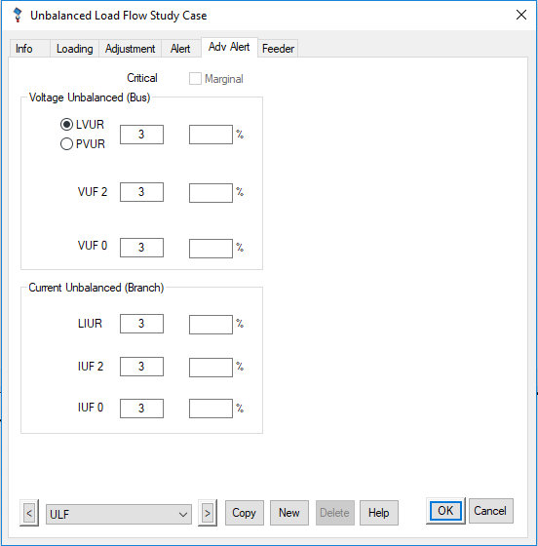
The Adv Alert page of the Unbalanced Load Flow Study Case editor is used to specify the setup of some advanced simulation alerts which are provided to notify you of an abnormal loading condition based on allowable percent values and system topology. The Simulation Alert System generates alerts when there is an overload in buses, transformers, cables, lines, panels, reactors, generators, power grid, and meters. The alerts are reported either graphically in the one-line diagram display or in the Alert View window.
Critical and Marginal Alerts
Simulation alerts generated after an Unbalanced Load Flow Study are either critical or marginal. Critical and marginal alerts use different percent value conditions to determine if an alert should be generated. If the condition for a critical alert is met, then an alert will be generated in the Alert View window and the overloaded element will turn red in the one-line diagram. The same is true for marginal alerts, except that the overloaded component will be magenta instead of red. Also, you must select the Marginal Limit option if you want marginal alerts displayed. If a device alert qualifies as both a critical and a marginal alert, only a critical alert is displayed.
Note: For ETAP to generate alerts for an element type, both the element rating and the percent value entered on the Alert page must be non-zero. The element ratings for alert checking are given in the following sections.
Voltage Unbalanced (Bus)
Voltage unbalanced (bus) alerts are generated if the percent voltage unbalance ratios resulting from the unbalanced load flow calculation exceed the specified percent values. These percentage voltage unbalanced ratios include those of line voltages, phase voltages, negative sequence voltages, and zero sequence voltages. Voltage unbalanced (bus) alerts report over-voltage unbalance ratio alerts.
Note: The voltage unbalance ratio (VUR) is the ratio of the maximum voltage deviation from the average voltage to the average voltage with the assumption that the average voltage is always equal to the nominal value.
LVUR
Select LVUR to use the unbalance ratio of line voltages.
The NEMA (National Equipment Manufacturer’s Association) definition of voltage unbalance, also known as the line voltage unbalance rate (LVUR) is given by:
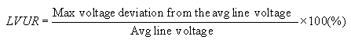
PVUR
Select PVUR to use the unbalance ratio of phase voltages.
The IEEE definition of voltage unbalance, also known as the phase voltage unbalance rate (PVUR) is given by:
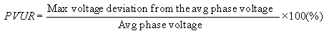
VUF 2
An index used in European standards to indicate the degree of unbalance is the voltage unbalance factor (VUF), which is the ratio of the negative sequence voltage to the positive sequence voltage and is given by:
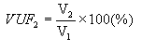
VUF 0 (VUF ₀)
The zero sequence voltage unbalance factor of phase voltages, which is given by:

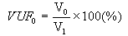
Current Unbalanced (Branch)
Current unbalanced (branch) alerts are generated if the percent branch current unbalance ratios resulting from the unbalanced load flow calculation exceed the specified percent values. These percent current unbalance ratios include those of branch currents, negative, and zero sequence branch currents. Current unbalanced (branch) alerts report over-current unbalance ratio alerts.
LIUR (IUR)
Branch current unbalance ratio (IUR), which is given by:
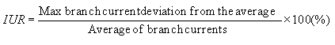
IUF 2 (IUF₂)
The negative sequence branch current unbalance factor, which is given by:
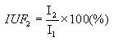
IUF 0 (IUF₀)
The zero sequence branch current unbalance factor, which is given by:
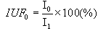
Meters
Meter alerts are generated if the percent meter measurements exceed the specified percent values. These percent meter measurements include those of Current, Voltage, MW, MVar, PF, and Freq. meter alerts report over-meter measurements alerts.
Feeder Page
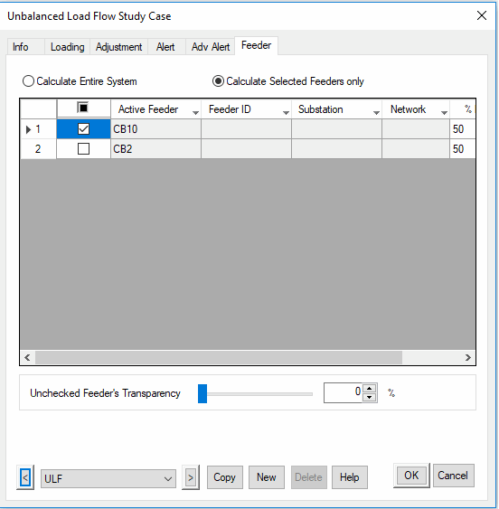
Calculate Entire System
Check this checkbox to perform calculation for the entire system.
Calculate Selected Feeders only
Check this checkbox and select the feeder to perform calculation for the selected feeder only.
Unchecked Feeder’s Transparency
This feature is for adjusting the transparency of the unchecked feeder. This feature is available in GIS view only.

Display Options
Results Page
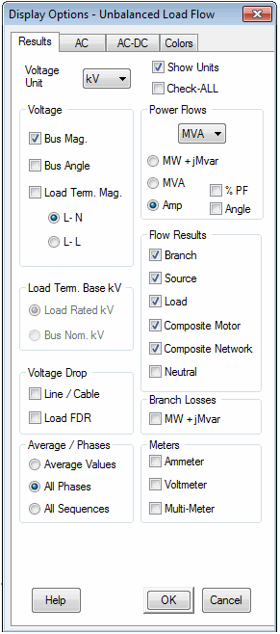
Show Units
Select this option to show units for power flow and current displayed on the one-line diagram.
Check-ALL
Select this option to show all available result annotations
Note: When this box is unselected, the previous settings are restored.
Voltage
In the Voltage list, select kV or % for voltage display on the one-line diagram.
Bus Mag.
Select this option to display bus voltages on the one-line diagram. Bus voltages are displayed at 15 degrees.
Bus Angle
Select this option to display bus angle in degree on the one-line diagram. Bus voltages are displayed at -15 degrees.
Load Term. Mag.
Select this option to display load (motors and static loads) terminal voltages on the one-line diagram. Load terminal voltages are displayed at 15 degrees. Load terminal voltages can be displayed based on load rated kV or bus nominal kV, depending on the option selected in the Load Term. Base kV group.
L-N
Select this option to display bus phase voltages on the one-line diagram.
L-L
Select this option to display bus line voltages on the one-line diagram.
Load Term. Base kV
This group allows you to select base kV for load terminal magnitude, but only when voltage is displayed in percent (% is selected in the Voltage list). This group will be disabled if voltage is displayed in kV.
Load Rated kV
Select this option to use load rated kV as the base for load terminal voltage display.
Bus Nom. kV
Select this option to use bus nominal kV as the base for load terminal voltage display.
Voltage Drop
Line/Cable
Select this option to display line and cable voltage drops on the one-line diagram.
Load FDR
Select a unit for power flow or current flow from the list to be displayed on the one-line diagram.
Average/Phases
Average Values
Select this option to display average values as shown in the following tables.
Phase Type | Voltage | Current | Power
3-Phase | Average Value | Average Value | Total Power
2-Phase | Average Value | Average Value | Total Power
1-Phase 3-Wire | Average Value | Average Value | Total Power
1-Phase 2-Wire | Phase Value | Phase Value | Phase Value
All Phases
Select this option to display individual phase values. For 3-phase element, voltage, current, and power for phases A, B, and C are displayed in sequence and for single-phase 3-wire element, voltage, current, and power for phases L1, N, and L2 are displayed in sequence.
Phase Type | Voltage | Current | Power
3-Phase | Phases A, B, & C | Phases A, B, & C | Phases A, B, & C
2-Phase | Phases A&B, B&C, or C&A | Phases A&B, B&C, or C&A | Phases A&B, B&C, or C&A
1-Phase 3-Wire | Phases L1, N, L2 | Phases L1, N, L2 | Phases L1, N, L2
1-Phase 2-Wire | Phase Value | Phase Value | Phase Value
All Sequences
Select this option to display individual sequence values for 3-phase elements.
Power Flows
In this group, you specify how the power flows will be displayed. From the Power Flows list, select the units (VA or kVA or MVA) to be used to display power flow on the one-line diagram.
kW + jkVar
Select the kW + jkVar option to display power flow in kW+jkVar or MW+jMVar, depending on the power flow units you are using.
kVA
Select the kVA option to display power flow in kVA or MVA, depending on the power flow units you are using.
Amp
Select the Amp option to display current flow in amperes.
%PF
When the Amp or kVA option is selected, you can select this option to show power factor of power flow along with the current.
Angle
When the Amp option is selected, you can select this option to show the current angle.
Flow Results
Branch
Select this option to display power flow through all branches on the one-line diagram. ETAP displays the power flow at the end of the branch that has a positive kW value flowing into the branch. For three-winding transformers, all three power flows are displayed.
Source
Select this option to display power flow for generators and power grids on the one-line diagram.
Load
Select this option to display power flow for motors, MOVs, capacitors, lumped loads, and static loads on the one-line diagram.
Composite Motor
Select this option to display power flow into composite motors.
Composite Network
Select this option to display power flow into composite networks.
Neutral
Select this option to display the neutral current. This option is only available when Amp is selected for Power Flows.
Branch Losses
Select this option to display branch losses on the one-line diagram. Losses are displayed inside a bracket in [kW+jkVar] or [MW+jMVar].
Meters
Ammeter
Select this option to display primary current for the branch to which an ammeter is attached.
Voltmeter
Select this option to display primary voltage for the bus to which a voltmeter is attached.
Multi-Meter
Select this option to display the measurements of a multi-meter, including bus voltage, branch current, branch power flow, power factor, and frequency.

AC Page
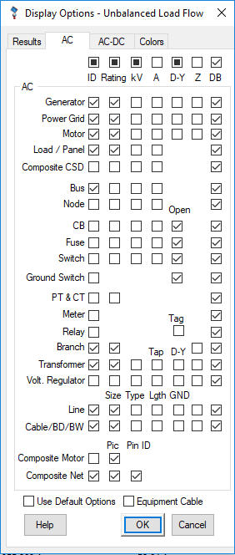
This page includes options for displaying info annotations for AC elements.
ID
Select the checkboxes under this heading to display the ID of the selected AC elements on the one-line diagram.
Rating
Select the checkboxes under this heading to display the ratings of the selected AC elements on the one-line diagram.
Device Type | Rating
Generator | kW / MW
Power Grid (Utility) | MVAsc
Motor | HP / kW
Load / Panel | kVA / MVA and connection type (# of phases - # of wires)
Composite CSD | kW / MW (Future)
Bus | kA bracing
Node | Bus bracing (kA)
CB | Rated interrupting (kA)
Fuse | Interrupting (kA)
PT & CT | Transformer rated turn ratio
Relay | Display Tag for OC, Multi-Function and MTR Relays
Branch, Impedance | Base MVA
Branch, Reactor | Continuous Amps
Transformer | kVA / MVA
Voltage Regulator | kVA / MVA
Line (size) | # of cables - # of conductor / cable - size
Cable / BD / BW (size) | # of cables - # of conductor / cable - size
kV
Select the appropriate checkboxes under this heading to display the rated or nominal voltages of the selected elements on the one-line diagram.
For transformers, the kV checkbox is replaced by %Tap checkbox which displays both transformer rated kV as well as total % Tap (Fixed Tap + LTC setting) for both 2-winding and 3-winding transformers.
For cables/lines, the kV checkbox is replaced by a ‘T’ button. Click this button to display the cable/line conductor type on the one-line diagram.
A
Select the appropriate checkboxes under this heading to display the ampere ratings (continuous or full-load ampere) of the selected elements on the one-line diagram.
For cables/lines, the Amp checkbox is replaced by an L button. Click this button to display the cable/line length on the one-line diagram.
For transformers, the Amp checkbox is replaced by the Tap checkbox. Select this checkbox to display the Fixed Tap value on the one-line diagram.
D-Y
Select the appropriate checkboxes under this heading to display the connection types of the selected elements on the one-line diagram.
For circuit breakers, fuses and switches, the D-Y checkbox is replaced with the N.O. checkbox. When checked, switching devices that are normally open have a N.O. designation on the one-line diagram.
For relays, the D-Y checkbox is replaced with the Tag checkbox. When checked, it displays user-defined tag for OC, Multi-Function and Motor Relays.
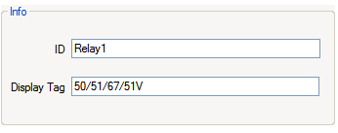
For transformers, the operating tap settings for primary, secondary, and tertiary windings are also displayed. The operating tap setting consists of the fixed taps plus the tap position of the Load Tap Changer (LTC).
Z
Select the checkboxes under this heading to display the rated impedance of the selected AC elements on the one-line diagram.

Device Type | Impedance
Generator | Subtransient reactance Xd”
Power Grid (Utility) | Positive Sequence Impedance in % on 100 MVA base (R + j X)
Motor | % LRC
Branch (Impedance and Reactor) | Impedance in % (R+jX) or Ohms
Transformer | Positive Sequence Impedance PS (%Z) for 2 winding transformer and PS/PT/ST (%Z) for 3 winding transformer
Voltage Regulator | Impedance (%Z) if included
Line | Positive Sequence Impedance (R + j X in ohms or per unit length)
Cable / BD / BW | Positive Sequence Impedance (R + j X in ohms or per unit length)
DB
Select the checkboxes under this heading to display the datablock for the selected device or element types.
GND
Select the checkboxes under this heading to display the IEC symbols for cables and transmission lines on the one-line diagram.
With current ETAP releases, for transmission line, the IEC symbols will show the phase conductor numbers as shown below. For cables, if the Neutral/Protective conductor(s) are specified on the Configuration page of editor, they will be shown on the one-line diagram as well.
Note: In order for a cable/line to be displayed as an IEC symbol, it must first be connected between two buses. Note also that the GND checkboxes are applicable only to the current mode.
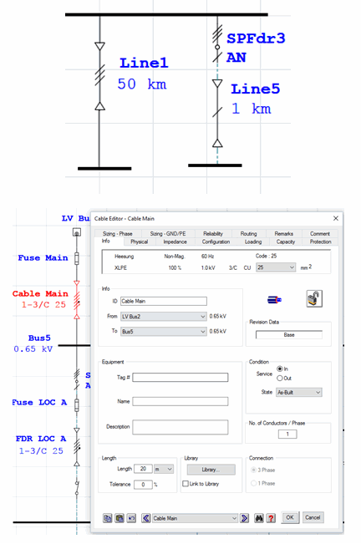
Composite Motor
Click on this checkbox to display the AC composite motor IDs on the one-line diagram, then select the color in which the IDs will be displayed.
Composite Network
Click on this checkbox to display the composite network IDs on the one-line diagram, then select the color in which the IDs will be displayed.
Use Default Options
Click on this check box to use ETAP’s default display options.
Equipment Cable
This checkbox displays or hides equipment cables from the one-line diagram. Equipment cables are specified as part of the loads. Double-clicking on the equipment cable will bring up the Equipment Cable Editor.
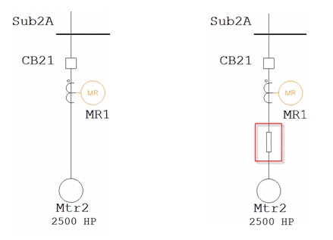

AC-DC Page
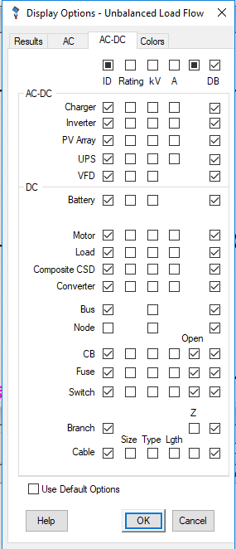
ID
Select the check boxes under this heading to display the IDs of the selected AC-DC and DC elements on the one-line diagram.
Rating
Select the check boxes under this heading to display the ratings of the selected AC-DC and DC elements on the one-line diagram.
Device Type | Rating
Charger | AC kVA & DC kW (or MVA / MW)
Inverter | DC kW & AC kVA (or MW / MVA)
UPS | kVA
VFD | HP / kW
Battery | Ampere Hour
Motor | HP / kW
Load | kW / MW
Composite CSD | kW / MW
Converter | kW / MW
Cable (Size) | # of Cables - # of Conductor / Cable - Size
CB | Rated Interrupting (kA)
Fuse | Interrupting (kA)
Switch | Rated Bracing Current (kA)
For cable, the Rating checkbox is replaced by a Size check box. Checking this option will display the size of the cable on the one-line diagram.
kV
Select checkboxes under this heading to display the rated or nominal voltages of the selected elements on the one-line diagram.
For DC elements, voltage units are changed from kV to V. For cables, the Voltage checkbox is replaced with the Type checkbox. When this checkbox is selected, cable conductor type (CU/AL) is displayed on the one-line diagram.
For cables the kV box is replaced by the Type checkbox. Checking this box will display the conductor type (Copper or Aluminum) of the cable on the one-line diagram.
A
Click on the check boxes under this heading to display the ampere ratings of the selected elements on the one-line diagram.
Device Type | Amp
Charger | AC FLA & DC FLA
Inverter | DC FLA & AC FLA
UPS | Input, output, & DC FLA
Motor | FLA
Load | FLA
Composite CSD | FLA
Converter | DC-DC Converter Input / Output FLA
For cables, the Amp check box is replaced by the Length checkbox. Select this checkbox to display the DC cable length (one way) on the one-line diagram.
For CB, Fuse and Switch, the N.O. checkbox displays the N.O annotation on the one-line diagram when the switching devices are in normally open state.
Z
Select the check boxes under this heading to display the impedance values of the cables and impedance branches on the one-line diagram.
DB
Select the checkboxes under this heading to display the datablock for the selected device or element types.
Use Default Options
Click on this check box to use ETAP’s default display options.
Colors Page
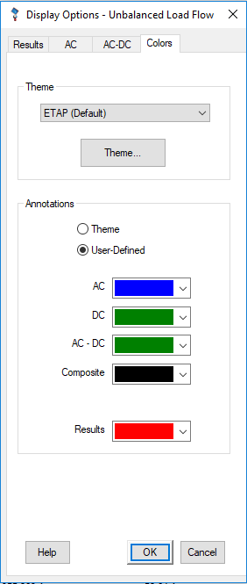
This page allows you to setup the colors used for displaying annotations on the one-line diagram.
Color Theme
Select the annotation colors specified in the Theme Manager by selecting the appropriate theme name.
Theme
Click this button to access the Theme Manager in order to quickly change the theme colors for annotations.
Annotations
Select the source of colors to be used for displaying annotations. Annotation colors can be used from the Display Options Editor or from the Theme Editor. By default, ETAP will use user-defined (Display Option Editor) colors to display annotation colors. Switch to Global Theme to use the selected theme annotation colors.
User-Defined
Select this option to specify a color for element annotations. When this option is chosen, the AC or DC element annotation color selection list will appear.
Theme Button
Click this button to make the Theme Editor appear.
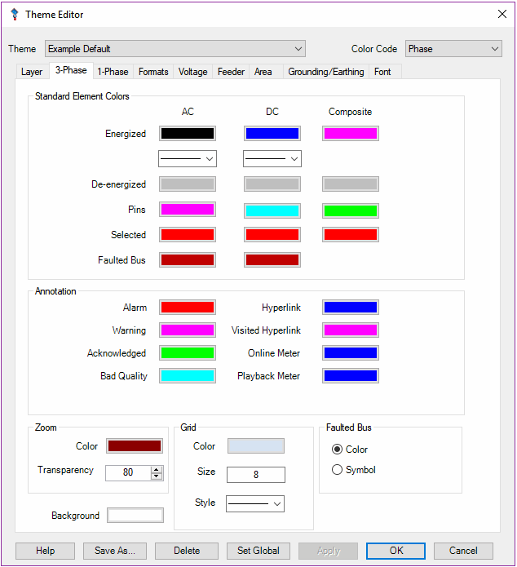
Theme Manager
The Theme Manager allows you to select existing color themes or define a new color theme.
Note: Color themes are applied globally within a project file. Changes made on a color theme displayed on this page may also affect other modes and presentations if the color themes option has been previously selected.
Colors
Select the color for information annotations to be displayed on the one-line diagram.
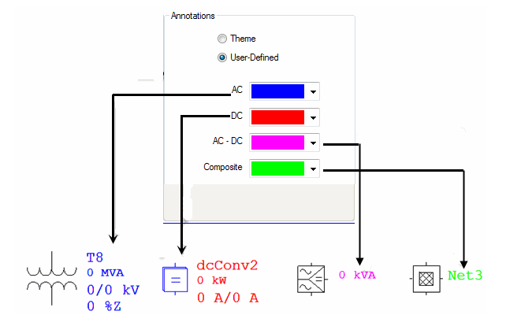

Alert Viewer
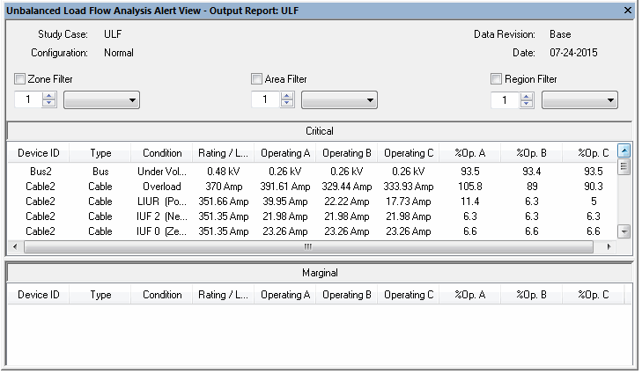
The Alert View contains a list of all the alerts generated by the unbalanced load flow calculation. The Alert View window may be configured to automatically display as soon as the unbalanced load flow calculation is over, by selecting the Auto Display option on the Alert page of the Unbalanced Load Flow Study Case. It may also be accessed by clicking the Alert View button. The Alert View provides tabulated columns of information about the reported alerts.
Device ID
The Device Identification column of the Alert View lists the names of all the components that qualified as alerts after the unbalanced load flow calculation.
Type
The Type column of the Alert View displays information about the type of device having the displayed alert.
Condition
The Conditions column of the Alert View provides a brief comment about the type of alert being reported. In the case of unbalanced load flow alerts, the different conditions reported are Overloads, Over Voltage, Under Voltage, Over Excited, and Under Excited.
Rating/Limit
The Rating/Limit column of the Alert View provides the rating information being used by the unbalanced load flow program to determine whether an alert should be reported and whether it is marginal or critical. For detailed information on alerts for each type of element, see the Alert Page section.
Operating A, B, and C
The Operating A, B, and C columns of the Alert View displays the results from the unbalanced load flow calculation. The results listed here are used in combination with those displayed in the Rating/Limit column to determine the operating percent values. These values are then compared to those entered in the Load Flow Study Case editor alarm page.
%Op. A, B, C
The %Value column displays the percent operating values calculated based on the unbalanced load flow results and the different element ratings. The values displayed here are directly compared to the percent of monitored parameters entered directly into the Alert page of the Unbalanced Load Flow Study Case editor. Based on the element type, system topology, and given conditions, the Alert Simulation program uses these percent values to determine if and what kind of alert should be displayed.

Output Reports
The unbalanced load flow calculation results are reported both on the one-line diagram and in Crystal Reports format. The graphical one-line diagram displays the calculated bus voltages, branch flows, and voltage drops, load power consumption, etc. You can use the Display Options editor to specify the content to be displayed. It also flags abnormal operating conditions, such as overloaded cables and over- or under-voltage buses, in different colors.
The Crystal Reports format provides you with detailed information for an unbalanced load flow analysis. You can utilize the Unbalanced Load Flow Report Manager to help you view the Output Report.
When unified load flow is enabled, AC and DC system will be reported separately in Crystal Reports.
View from Study Case Toolbar
This is a shortcut for the Report Manager. When you click the View Output Report button, ETAP automatically opens the output report listed in the Study Case toolbar with the selected format. In the picture shown below, the output report name is ULF and the selected format is Cable.
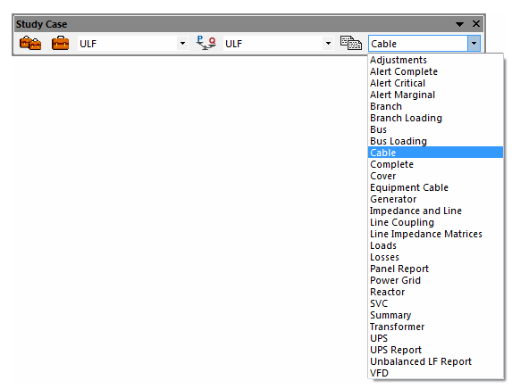
Report Manager
To open Report Manager, click the Report Manager button on the Unbalanced Load Flow toolbar. The editor includes four pages (Complete, Input, Result, and Summary) representing different portions of the output report. The Report Manager allows you to select file types available for different portions of the report and view it via Crystal Reports. There are several fields and buttons common to every page, as described below.
Viewer and File Options
You can view the report in the Crystal Reports viewer, or save the report in PDF, MS Word, Rich Text Format, or Excel format. If you wish this selection to be the default for reports, click the Set As Default check box.
Output Report Name
This field displays the name of the output report you want to view.
Path
This field displays the name of the project file based on which report was generated, along with the directory where the project file is located.
Help
Click this button to access Help.
OK/Cancel
Click OK to close the editor and open the Crystal Reports view to show the selected portion of the output report. If no selection is made, it will close the editor. Click Cancel to close the editor without viewing the report.
Input Data
This page allows you to select different file types for viewing input data, grouped according to type. They include:
Adjustments
Branch
Bus
Cable
Cover
Equipment Cable
Impedance and Line
Line Coupling
Line Impedance Matrices
Reactor
SVC
Transformer

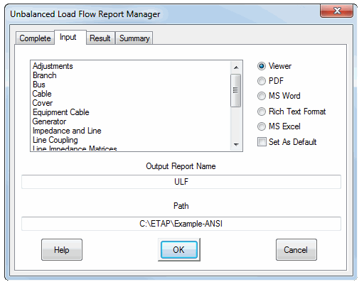

Result
This page allows you to select file types to view the load flow result portion of the Output Report.
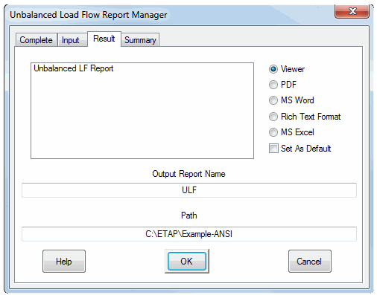
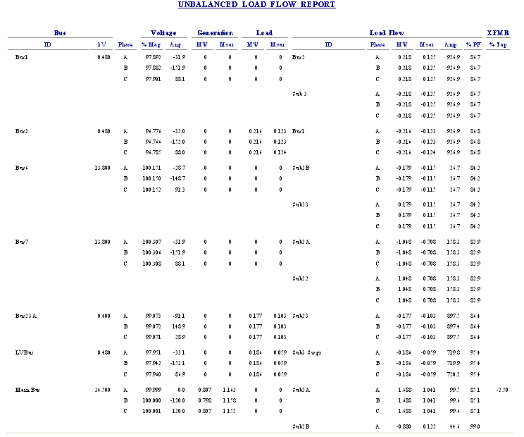
Summary
This page allows you to select different portions of the load flow summary to view.
Note: Some portions of the summary are available only when you select specific options in the Study Case, such as critical and marginal voltage options.
Alert-Complete
Alert-Critical
Alert-Marginal
Branch Loading
Bus Loading
Losses
Summary
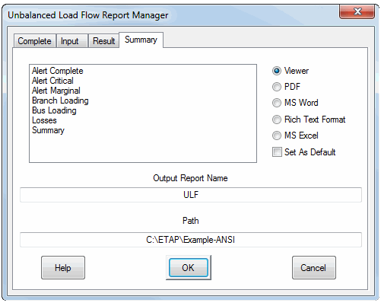
Complete
The only file type available on this page is Complete, which brings up the Complete Report for the Load Flow Study. The Complete Report includes Input Data, Results, and Summary Reports.
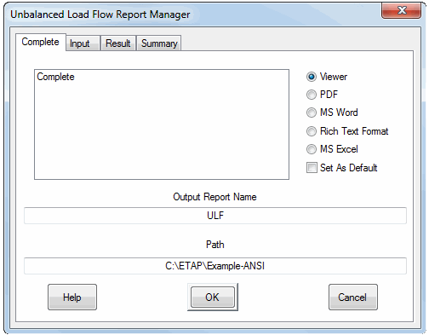
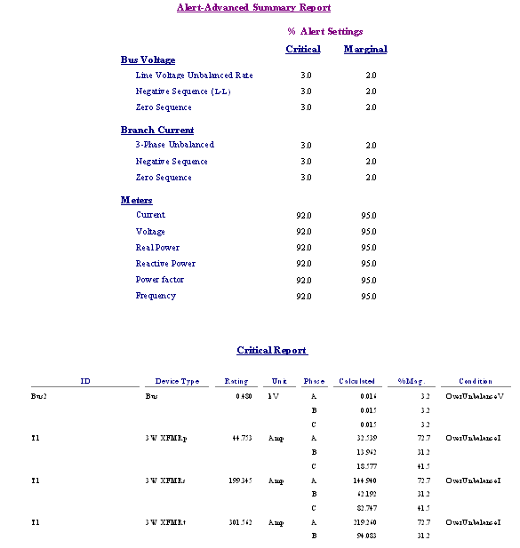

Distribution State Estimation (DSE)
Distribution State Estimation (DSE) module, also called load allocation(LA), is similar to SLE, however, provides a much more accurate and powerful analysis in the distribution system. DSE engine will use the measurements on the feeder level, transformer level and customer level to perform calculation, and estimate the loading on the entire distribution system or on the selected feeder. It provides the estimated loading, technical losses and nontechnical losses. Technical losses include the line loss and transformer loss, while nontechnical losses include losses due to power theft, modelling mismatch and system configuration mismatch.

The load allocation viewer will be launched from the Load Allocation toolbar. Load Allocation engine takes the available measurements and assign load to the downstream. It is required that on the Feeder Level, measurements of per phase active power, reactive power and voltage have to be provided in order for LA engine to calculate.

Load Allocation Viewer:
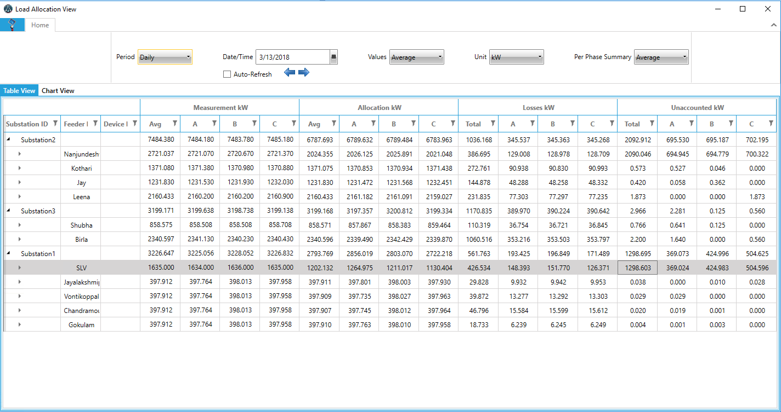
Period: Drop Down
•15 Minutes (See Configuration Details)
•Hourly
•Daily
•Monthly
•Yearly
Date/Time: Calendar Element
•If Period = 15 Minutes: Calendar is set to current 15 minute period by default. Include hour and minute in Calendar picker.
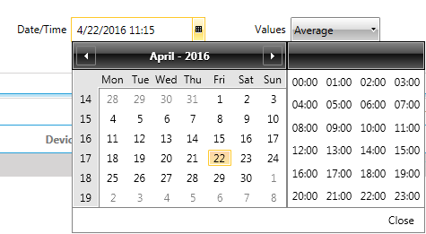
Values:
•Average (Default)
•Min
•Max
•Last
•Energy: If this is selected change from MW to “MW Hour” in headers.

Units: This defines the scaling factor. Change the scaling and header based on units desired.
•W
•kW
•MW
The accumulation report is based on 15 minute period. The viewer follows the following logic:
- If Period = 15 Minutes
- If Values = Average: Show the average value for the 15 minute period
- If Values = Minimum: Show the minimum value for the 15 minute period
- If Values = Maximum: Show the maximum value for the 15 minute period
- If Values = Energy: Show the totalized value for the 15 minute period
- If Period > 15 Minute
- If Values = Average: Show the average of all 15 minute average samples
- If Values = Minimum: Show the minimum of all 15 minute minimum samples
- If Values = Maximum: Show the maximum of all 15 minute maximum samples
- If Values = Energy: Show the sum of all 15 minute totalized samples
The instantaneous losses calculations are performed by load allocation, but the accumulation of the results over the 15 period is performed by a separate process. The mentioned process follows the next rules:
- Distribution Transformer Data
- Associated Feeder
- Associated Substation
- Measured MW (A/B/C) – Average, Min, Max, Last, Totalized
- Allocated MW (A/B/C) – Average, Min, Max, Last, Totalized
- Loss MW (A/B/C) – Average, Min, Max, Last, Totalized
- Unaccounted MW (A/B/C) – Average, Min, Max, Last, Totalized
- Feeder Data
- Associated Substation
- Measured MW (A/B/C) – Average, Min, Max, Last, Totalized
- Allocated MW (A/B/C) – Average, Min, Max, Last, Totalized
- Loss MW (A/B/C) – Average, Min, Max, Last, Totalized
- Unaccounted MW (A/B/C) – Average, Min, Max, Last, Totalized
- Substation Data
- Measured MW (A/B/C) – Average, Min, Max, Last, Totalized
- Allocated MW (A/B/C) – Average, Min, Max, Last, Totalized
- Loss MW (A/B/C) – Average, Min, Max, Last, Totalized
- Unaccounted MW (A/B/C) – Average, Min, Max, Last, Totalized
- Totalized means the integral of the value over the 15 minute period.

Load Allocation Configuration

Load Allocation Toolbar
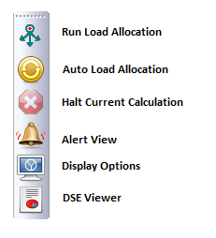
Run Load Allocation
Run Load Allocation based on setting in study case
Auto Load Allocation
When offline using external data, this is based on the time specified in the file. When Running Online, it will be triggered automatically
Halt Current Calculation
Abort current Load Allocation calculation
Alert View
Show Alerts based on alert setting
DSE Viewer
Click to launch Distribution State Estimation (DSE) Viewer. It is also called Load Allocation Viewer

Load Allocation Study Case

Info Page
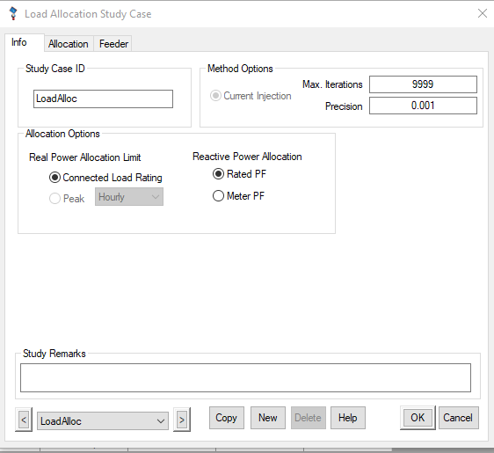
Specify the calculation method details. User could also specify which power factor to use for allocation
Allocation Page
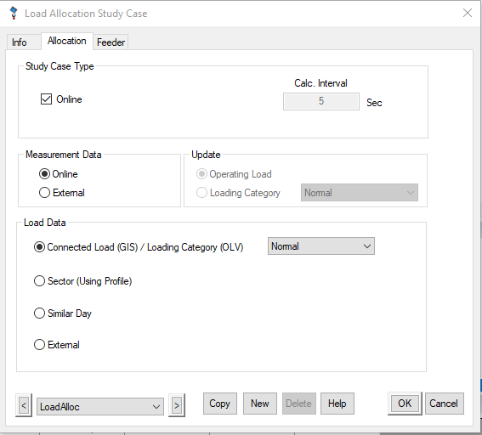
Configure this page to separate calculation online/ offline.
Study Case Type
Specify if this is an online study
Measurement Data
Choose online to use measurement when online. Choose External when offline study is intended
Update
Only used for offline study. It will update the load data in the editor.
Load Data
This will specify the limiting point to be allocated to load:
- Connected Load (GIS) / Load Category (OLV): For GIS, load rating will be the limit. For OLV, use specified Load Category to limit load allocation
- Sector (Using Profile): Use Profile to specify the load limit. Currently not fully implemented.
- Similar Day: Currently not implemented. It will use forecasting data to decide the limit of the load.
- External: Currently only used for offline. It will use data in excel file to be considered as measurement on the Feeder Level.
Feeder Page
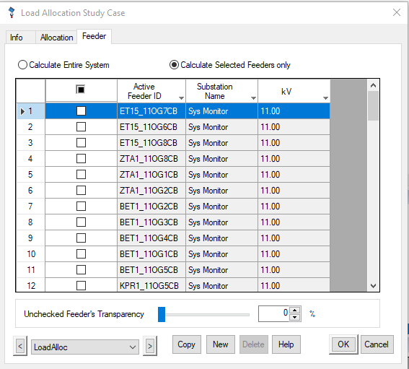
Choose the feeders that are required to run Load Allocation

Load Allocation Report
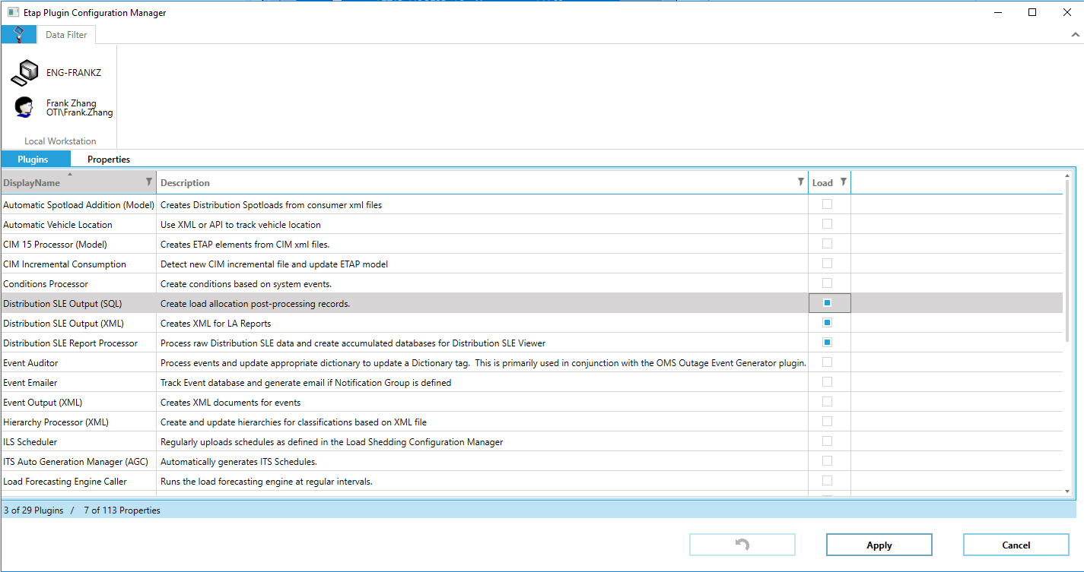

Load Allocation report is summarized by enabling plugin in ETAP Notifier Plugin Manager:
- Distribution SLE Report Processor:
This is the one used to summarize the results generated by engine and create report. User can specify the calculation rate.
- Distribution SLE Output ( XML ):
This will export LA report into XML format. User can specify the folder and export rate
- Distribution SLE Output ( SQL):
This is not implemented. This is supposed to export report into SQL database.

Volt-Var Optimization
Volt-Var optimization (VVO) finds and sets the optimum setting of voltage and VAR control devices (LTCs, Voltage regulators and switch capacitors) in distribution system considering objectives and constraints. It is a centralized Volt-Var optimization and control for Distribution Management System (DMS). Main objective of VVO is to make distribution grid (1) more efficient (because of less power loss) and (2) to reduce peak demand or conservation of volt reduction (CVR) for running utilities with less cost. Here state Variables are discrete values for the setting of LTCs, voltage regulators and switch capacitors.

Local Vs Centralized Volt-Var Optimization:
Because of the diversity of the actual operating conditions resulting from changes in power demand and configuration, it is not feasible for local controller approach to provide settings which will be effective for all feasible conditions. Changes of voltage level of one part of the system, may need to change tap settings not only its immediate upstream one (i.g., local setting), but also all the upstream series transformers, voltage regulators and connected capacitors (i.e., global or centralized). Using only local measurements, without taking into account the requirements of the whole power system, opportunities for global Vol-Var optimizations are missed. Therefore, centralized VVO is needed and is optimal at the system level, not just at the local level.
Objectives
- Conservation Voltage Reduction (CVR) - Peak Shaving or Reduce Peak Demand
- Minimize Power Loss (efficient VAR Flow)
- Optimize Voltage Profile (Volt-Var)

All objectives need coordinated control that can be achieved from two-way communication of smart because one objective will affect other.
Conservation Voltage Reduction (CVR) - Peak Shaving or Reduce Peak Demand
It minimizes voltage profile at min limit (e.g. 95%) using voltage regulators and LTCs. It is for power conservation and energy efficiency. People call energy efficient because it needs less power for utilities to serve customers.
Minimize Power Losses (efficient Var Flow)
It minimizes Var flow over miles of distribution feeder. Switch capacitors (shunt compensation) can supply proper reactive power locally to minimize reactive power flow from upstream sources. Thus, it reduces power losses. It can be called efficient power distribution because of less power losses in distribution grid.
Optimize Voltage Profile
It optimizes voltage profile near to 100% using voltage regulators and LTCs.
State Variables/Candidates
Voltage regulators, LTCs and switch capacitors are discrete state Variables/candidates for VVO. Inverter is not considered for this project.
VVO Trigger/Time Step
Trigger VVO in every predefined periodic time interval (time step, T) or when any regulatory limit, e.g., voltage is violated.
Applications/Advantages:
- Efficient distribution grid
- Less operation cost for utilities
- Less CO2 emission as less power will be served to customers without the violation of any regulatory limit (smart-grid application)
- Coordinated control of LTCs, voltage regulators and switch capacitors from two-way communications facilities of smart-grid

For this project, VVO engine will use the estimated loading from LA engine to run calculation.

Note: Usually inverters for distributed renewable energy (DRE) PV arrays and generator AVR/exciter are not controlled for VVO. However, for large PV generator, it is feasible to control inverter voltage. Inverter control is not considered for this project.
The American National Standards Institute (ANSI) standard C.84.2 standard requires the customer voltage to be within a ±5% range (114V-126V for 120V base). If the voltage on a system is outside of this range, the utility may be fined and receive customer complaints.

VVO Toolbar
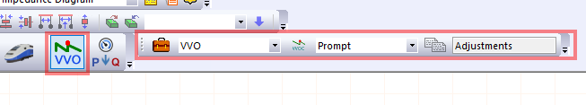
In VVO mode, the action buttons include Run VVO, Halt Current Calculation, Alert, Report Manager, Display options, Get On-line Data, Get Archived Data.
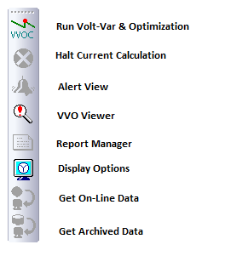

VVO Mode should be active in both OLV and GIS view.

When online, VVO engine will be running based on advisory mode or supervisory mode. In advisory mode, the recommendations from VVO engine will be shown, but will not send control signals. User has option to send control manually in advisory mode. In supervisory mode, control will be sent automatically based on specified time range and maximum switching per day per type of devices.

Run Volt-Var & Optimization
When modelling of required components are ready, running VVO based on study case as below:
1. Select a study case from the Study Case editor.
2. Click the Run Volt-Var & Optimization button to perform a VVO study.
A dialog box appears. Specify the output report name if the output file name is set to Prompt. The study results appear on the one-line diagram and in the output report.
Halt Current Calculation
Abort the current calculation
Alert View
Show/ Hide the Alert
VVO Viewer
Show/ Hide the VVO results
Report Manager
Create output report based on the selected information.
Display Options
You can customize the OCP one-line diagram annotation display options.
Get On-Line Data
This button is active when ETAP Real-Time Advanced Monitoring is online. Click on this button to use the current real-time data as initial conditions.
Get Archived Data
This button is active when ETAP Real-Time Event Playback is online. Click on this button to use the selected archived data as initial conditions for this analysis.

Study Case Design
Info Page
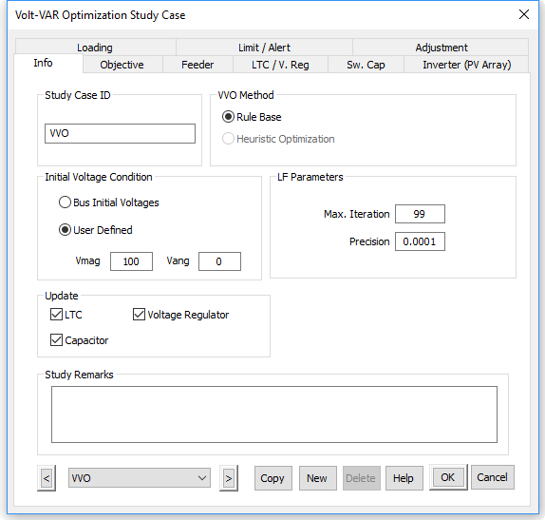

Study Case ID
It shows name of the study case. Example: VVO.
LF Parameters:
- Max. Iteration: Default value is 100. Min and max values are 1 and 99999, respectively. It will be used by LF engine.
- Precision: Default value is 0.00001 pu. Min and max values are 0.000001 pu and 0.1 pu, respectively. It will be used by LF engine.
Initial Voltage Condition
It is used in load flow calculations from where LF engine starts.
Update
- LTC: Checked by default.
- Voltage Regulator: Checked by default.
- Capacitor: Checked by default.
Study Remarks
Use for texts to save comments.
VVO Method
Currently only rule based method is implemented.
- Rule 1: For voltage optimization (CRV or optimize voltage profile), it searches candidate LTCs/Voltage regulator from upstream feeder to end users. Then find tap of each LTCs/Voltage regulator from most upstream side one by one.
- Rule 2: For minimize losses (actually minimize VAR flow), it searches candidate switch capacitors from end users to upstream feeders. Then increase active number of switch capacitor banks one at a time.
Objective Page
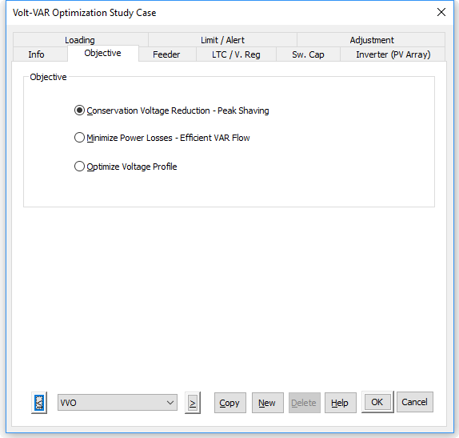
Objectives
- Conservation Voltage Reduction - Peak Shaving
- Minimize Power Loss - Efficient Var Flow
- Optimize Voltage Profile
Conservation Voltage Reduction (Reduce Peak Load Demand):
It tunes(adjusts) LTCs at s and voltage regulator settings to maintain minimum regulatory voltage limit (e.g. 95%) at the last node users so that demand is minimum because most of the distribution loads are voltage dependent constant impedance loads.
Minimize Power Losses (efficient/ minimum VAR flow):
It tunes/adjusts candidate switch capacitors settings to minimize Var flow along miles of distribution feeder (using 2/3 rules). Then it will check voltage whether any voltage limit is violated or not. If there is no voltage violation, it is done. If any voltage limit is violated, then tune candidate LTCs/voltage regulator.
2/3 Rule: Place a capacitor equal to two-thirds the Var load of the feeder at a point two-thirds of the distance from the substation (therefore 2/3 VAR at 2/3 distance from feeder).
Optimize Voltage Profile:
For "Optimize Voltage Profile" objective, voltage profile will be shifted/lifted/boosted up or down from each LRC/voltage regulator location so that middle of max voltage and min voltage will be centered at 100%. However, pattern will be the same.
It tunes LTCs/voltage regulator. To optimization voltage profile, it searches candidate LTCs/voltage regulator from feeder to end users. Then increase Tap of each LTCs/voltage regulator one at a time.

Feeder Selection Page
User can select as well as ignore any number of feeders for VVO study.
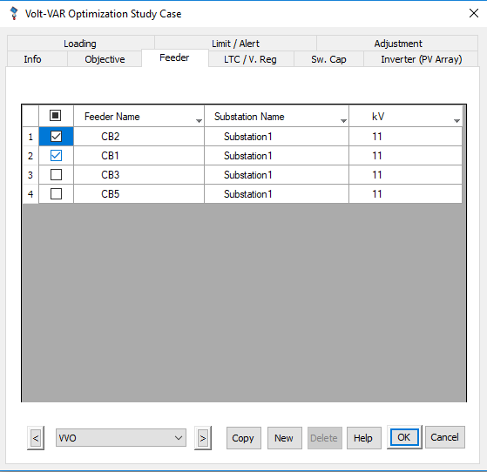
Capabilities of this table:
  - Serial number to count number of feeders
  - Selection checkbox to select and unselect feeders for VVO study
  - Feeder Name:
Name will be populated from feeder CB elements. A feeder might be de-energized by opening an upstream CB or users can make a feeder CB out of service. The de-energized feeder will not be displayed, even though the feeder was selected initially. The feeder will be automatically visible again, once the feeder is re-energized again.
If "Association" has valid text for ID field, use that ID as Active Feeder ID. Otherwise use Feeder CB name as Active Feeder ID.
  - "Substation Name" will be populated from Substation element.
  - kV is populated from CB nominal voltage of source side.
  - All columns have sorting and filter capabilities. However, selected feeders will not be affected by sorting and filtering.
  - If you double click on an ID, it will show the feeder section in the GIS view. Only check boxes are editable. All other fields are display only.

LTC and Voltage Regulator Selection Page
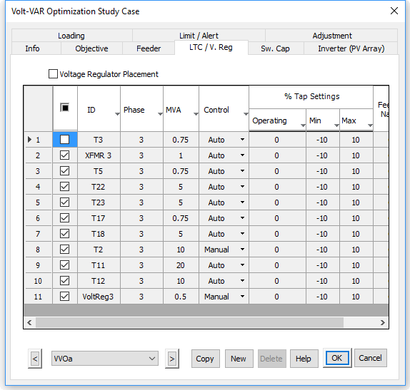

By default, "Voltage Regulator Placement" is unchecked. In this case, all transformers(LTCs) and voltage regulator under selected feeder will be displayed in the table.
If "Voltage Regulator Placement" is checked, two options (radio button) will be availble for "New Voltage Regulator" (by default) and "Relocation" of exisiting voltage regulators. If "New Voltage Regulator" is chosen, voltage regulator entries in the table will be grayed out because engine will find new volt. regulators and not editable any field. If "Relocation" is chosen, all entries in the table will be visible.
Note that "New Voltage Regulator" or "Relocation" are only for voltage regulator, but not for transformers(LTCs). These two options are not finalized yet.

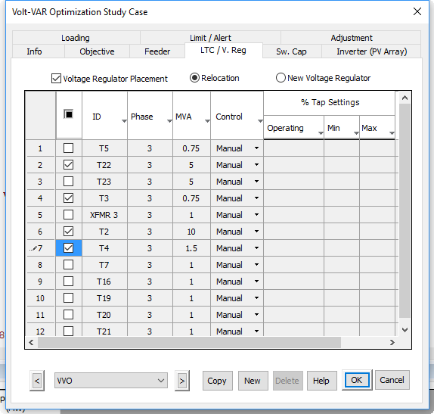
- All LTCs/voltage regulators under the selected feeders will be showed up in Table.
- By default, all LTCs/voltage regulators will be checked automatically. Because it is an optimistic idea that most of the cases all the LTCs/voltage regulators are changeable.
- In the table, all columns have sorting capabilities like Excel.
- If you double click on an ID, it will bring the element on GIS.
- Initial. Tap will come from "Manual or Operating Tap" or Real-Time Scanned field. For empty fields, Initial. Tap will be 0.0. At initial LF, engine can start from Initial. Tap. Secondly, Initial. Tap will also be used to compare with Final Tap setting after running engine.
- Max and Min tap setting will come from Tap page of each transformer (please see Tap page ->LTC/Voltage Regulator section->Tap section) and voltage regulator (please see Tap page ->Tap section).
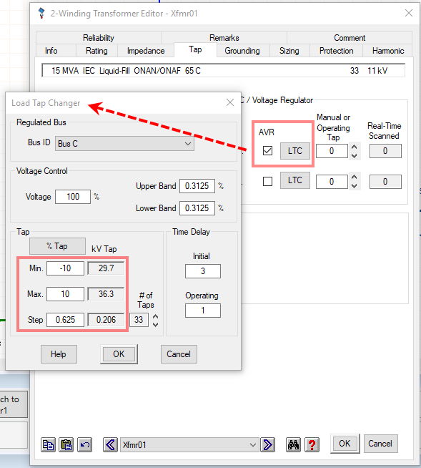
Only check box field is editable. All other fields are display only.

Switch Capacitor Selection Page
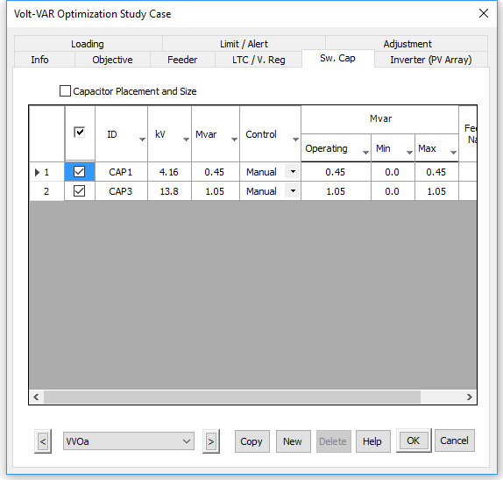
- By default, "Capacitor Placement and Size" is unchecked. In this case, all capacitors under selected feeder will be displayed in the table.
- If "Capacitor Placement and Size" is checked, two options (radio button) will be available for "Relocation" and "New Proposed Location". If "Relocation" is chosen, all entries in the table will be visible. Relocation and New proposed location are not finalized yet.
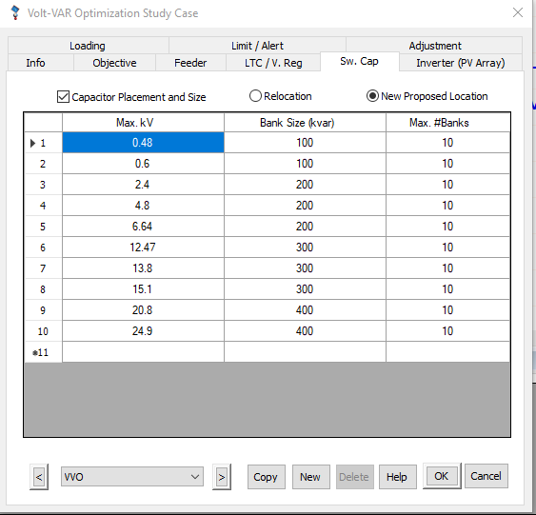

If "New Proposed Location" is chosen, capacitors information table will come. Users can add delete and edit this table.
- All switch capacitors under the selected feeders will be showed up in the Table.
- By default, all switch capacitors will be checked automatically. Because it is an optimistic idea that most of the cases all the switch capacitors are changeable. However, selection check box is editable.
- Initial. MVar will come from "Operating Load" at Rating tab of Capacitor element. Min MVar is 0.0 always because and Max MVar is from Loading section depending on Design, Brake, Full Load, etc. of Rating tab. Show absolute values of Initial. MVar, Min MVar and Max MVar as rating (not loading).
- In the table, all columns have sorting capabilities like Excel.
- If you double click on an ID, it will bring the element on GIS or OLV.
- Feeder is the dynamic feeder of the Capacitor.

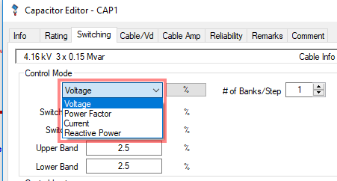
Loading Page
- Loading Category
- Generator Category
- Charger Loading
- Load Diversity Factor
- Single Load Flow Calculation: The time selection is currently not considered. This only will run load flow based on current loading.
- Time Domain Simulation: This has not been fully implemented

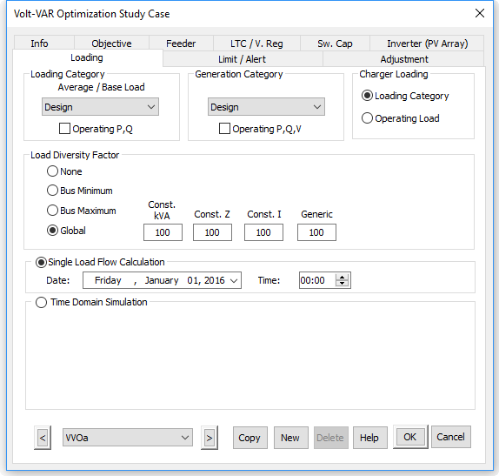

Limit Page
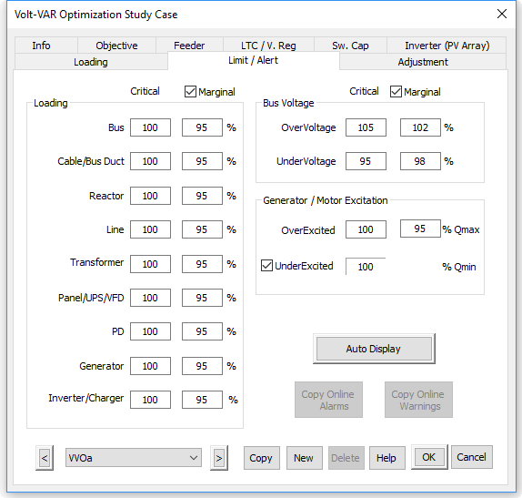

Critical "Under Voltage" value will be used for Conservation Voltage Reduction objective.

Adjustment Page
Same as the Adjustment page of unbalanced load flow module.

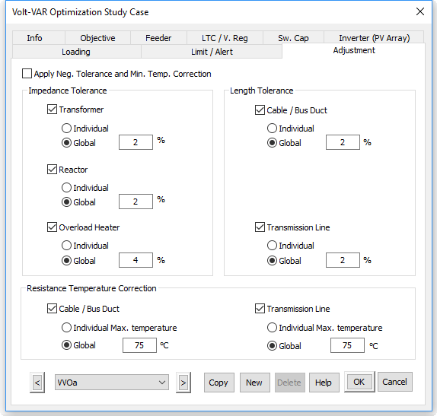

Note: By default, no one is checked.

Results Display for VVO
- ULF results with optimum setting
- Show settings of LTCs, volt regulators and switch capacitors near elements. In the OLV display below, settings could be shown in datablock.
- Honor "Update" section for LTC, voltage regulator and capacitor check boxes in study case Info page.
  - If checked, update/over-write by calculated values and show final load flow results on OLV.
  - If not checked, no need to update but show previous existing values. In that case, final load flow results on OLV will not be changed. Even though, new settings are not updated, results of new values will be shown in system manager and report.

VVO Viewer
It has 6 tabs – Losses, Conservation Volt, Peak Shaving, LTC/ V.Reg, Sw. Cap and Inverter. It will show both losses and voltage (max and min) of all the feeders.
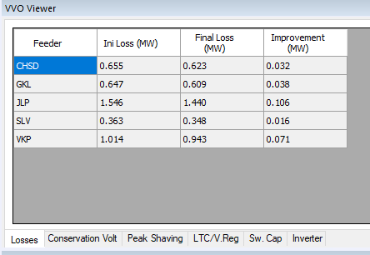
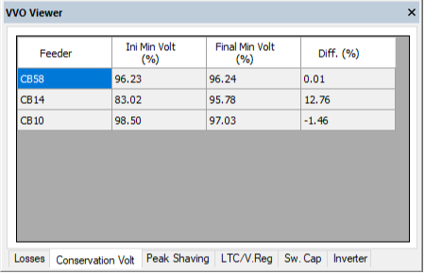
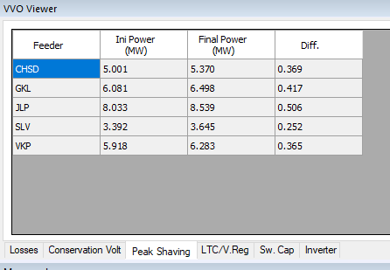
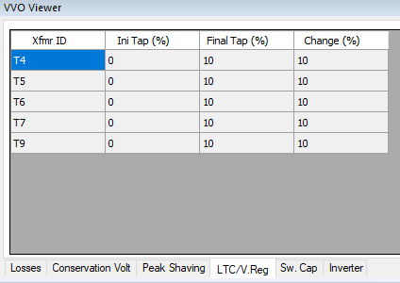
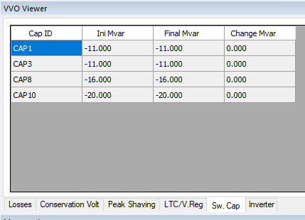
Inverter is not supported by the engine yet.
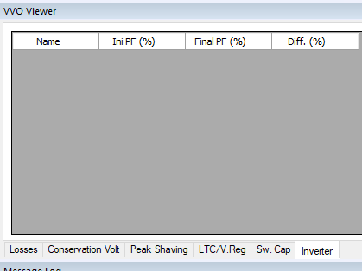
Display Option
Show the following Display Options on the OLV and OLV GIS.
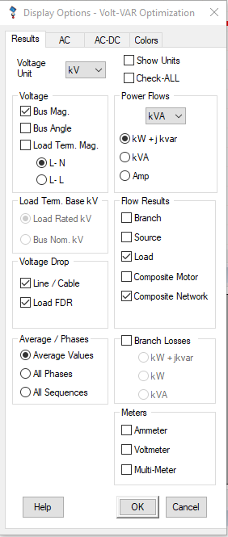
Show the following Display Options on the GIS view.

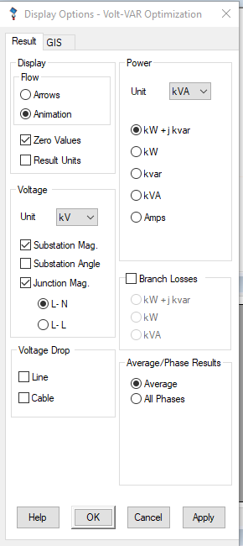

Alert
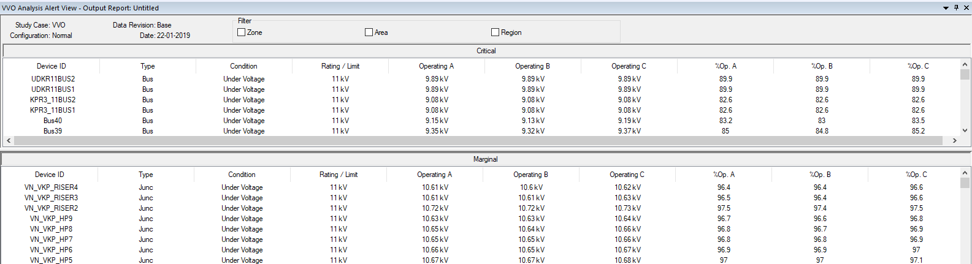

If both critical and marginal limits are the same, in that case critical warning will be shown.

Output Reports for VVO
VVO provides detailed report on the study results including the switching actions and system voltage/VAR levels before and after switching.
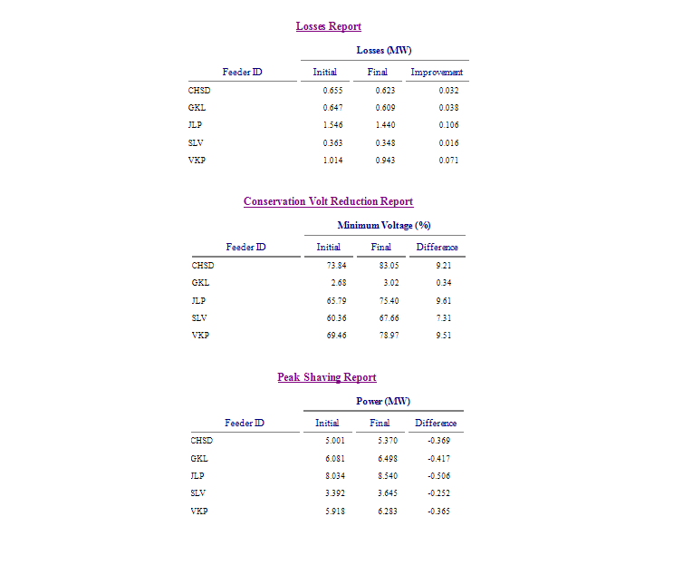

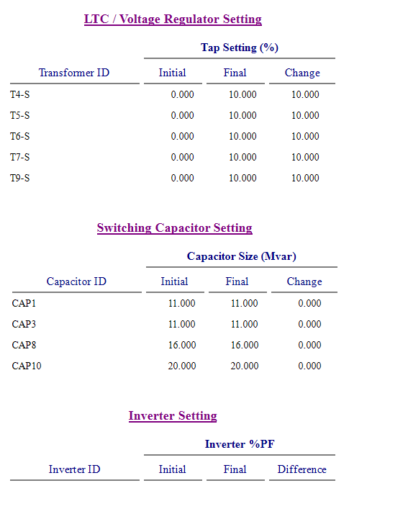
VVO Web Application
In VVO web view, user will be able to do the following:
- Switch between advisory mode and supervisory mode
- Specify the time range to send control signals and the maximum switching per day per type of devices
- Request VVO engine calculation on demand
- View the recommended switching based on the time selected
- View the controls sent per recommendation and highlight the failed command
- View the power needed before and after the VVO recommendation
- View the power losses before and after the implementation of VVO recommendation
- View the voltage range before and after the implementation of VVO recommendation

Optimal Capacitor Placement (OLD only)
The majority of power systems operate at a lagging power factor due to inductive loads and delivery apparatus (lines and transformers). Power systems are inductive in nature, and require additional reactive power flow from the power grid. But excessive reactive power demands result in reduced system capacity, increased losses, and decreased voltage, as well as higher operating costs. Shunt capacitor banks are able to compensate for Var requirements, but bank size, location, the capacitor control method, and cost considerations are important issues that need to be optimized during the design phase. An ideal solution would be a capacitor placement tool able to weigh all these factors and that considers load levels. This solution should also be able to place capacitors for voltage support and power factor correction, while minimizing the total cost of installation and operation. ETAP now provides just such an application in its Optimum Capacitor Placement (OCP) module. Note that OCP module is based on balanced load flow.
As described in the IEEE Standard 1036-1992 (IEEE Guide for Application of Shunt Power Capacitors), the purposes of shunt capacitor applications are:
- Var support: Yields a primary benefit for transmission systems and a secondary benefit for distribution systems.
- Voltage control: Yields a primary benefit for both transmission and distribution systems.
- System capacity increase: Yields a secondary benefit for transmission systems and a primary benefit for distribution systems.
- System power loss reduction: Yields a secondary benefit for transmission systems and a primary benefit for distribution systems
- Billing charge reduction: Does not apply to transmission systems, but yields a primary benefit for distribution systems.
To place shunt capacitors in power systems, it is necessary to:
- Determine bank size in kVar
- Determine connection location
- Determine a control method
- Determine a connection type (wye or delta)
The capacitor size and the appropriate location for voltage support and power factor correction can be determined in different ways. A common method applies “rules of thumb” techniques, and then runs multiple load flow studies to fine-tune the size and location. Unfortunately, this method may not yield the optimal solution. And it can also be very time consuming and impractical for large systems.
It is also important to minimize cost, while mathematically determining the capacitor size and location. Because this is an optimization issue, an optimization approach should be employed. This is where the ETAP OCP module excels. It is an extremely powerful simulation tool specifically designed for this application. The OCP module allows you to place capacitors for voltage support and power factor correction while minimizing total cost. The advanced graphic interface provides the flexibility to control the capacitor placement process, while allowing you to view the results instantly. The precise calculation approach automatically determines the best location and bank sizes. In addition, it reports the branch capacity release and savings during the planning period due to Var loss reduction.

Optimal Capacitor Placement Toolbar
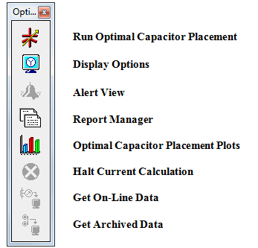
Run Optimal Capacitor Placement
Clicking this icon launches the OCP calculation. All required data must have been entered into the device and study case pages prior to running an optimal capacitor placement calculation, otherwise an error report will be generated. The error report will list the problems encountered. When these issues are resolved, the calculation will be processed automatically.
To generate OCP reports for a study:
In OCP Mode, select an output report name from the Output Report List, then select a report format from the Report Manager.
Click the Report Manager button.
Display Options
You can customize the OCP one-line diagram annotation display options:
In OCP mode, click the Display Options button.
For detailed information on using these Display Options section of this chapter.
Alert View
The Alert View button is not enabled for this release.
Report Manager
Clicking on the OCP Report Manager icon provides access to the following report configuration pages:
- Complete
- Input
- Result
- Summary

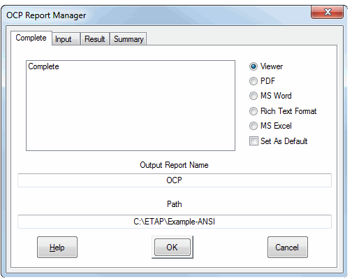
For example, to open the OCP Report Manager and select a specific report for review, follow these steps:
- Click the Report Manager button from the Study toolbar to display the OCP Report Manager. Select a format for the output files by clicking on its button in the right-hand column.
- Click the Result page.
- Select one of the report types displayed. (Clicking “Set as Default” sets the selected format for all subsequent reports.
- Click OK to display the output report.

Optimal Capacitor Placement Plots
To view optimal capacitor placement plots, follow these steps:
- Click the OCP Plots button on the Study toolbar. The selection dialog box appears.
- Select from the combination of plots to view; Loss Reduction Saving During Planning Period, Capacitor Operation Cost During Planning Period, and Profit During Planning Period.

Halt Current Calculation
To stop the current OCP calculation, click the Halt Current Calculation button (a red circle with an X icon on the OCP toolbar).
Note: The Halt Current Calculation button is normally disabled. When an OCP calculation begins, this button becomes enabled and appears as a button with a red circled X icon. If you terminate the calculation before it completes, one-line diagram displays will not be available, and the output report will be incomplete.
Get On-Line Data
This button is active when ETAP Real-Time Advanced Monitoring is online. Click on this button to use the current real-time data as initial conditions.
Get Archived Data
This button is active when ETAP Real-Time Event Playback is online. Click on this button to use the selected archived data as initial conditions for this analysis.

Optimal Capacitor Placement Study Case
The Optimal Capacitor Placement (OCP) Study Case Editor contains solution control Variables. ETAP allows you to create and save an unlimited number of study cases for each type of study. Just as in other study types, it is possible to switch between different OCP study cases. This feature allows you to organize study efforts and save time.
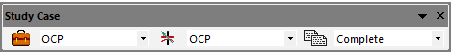
In the OCP mode, the Capacitor Placement Study Case Editor can be accessed by:
- Clicking on the Edit Study Case button on the Study Case toolbar shown above.
Note: The Study Case Editor can also be accessed from the System Manager by clicking the Capacitor Placement subfolder in the Study Case folder.

A Study Case can be used for any combination of configuration status; one-line diagram presentation, and base/revision data. The Capacitor Placement Study Case Editor consists of the following pages:
- Info
- Loading
- Bus kV Constraint
- Power Factor Constraint
- Capacitor
- Adjustment

To create a new OCP study case, simply:
- Go to the System Manager.
- Right-click on the Capacitor Placement subfolder inside the Study Case folder.

- Select “Create New”.

Note: A new study case can also be created by clicking the New button on the OCP Study Case toolbar.
The module creates a new study case, which is a copy of the default study case. This can be added to the Optimal Capacitor Placement subfolder.
A graphic example of this is shown below:

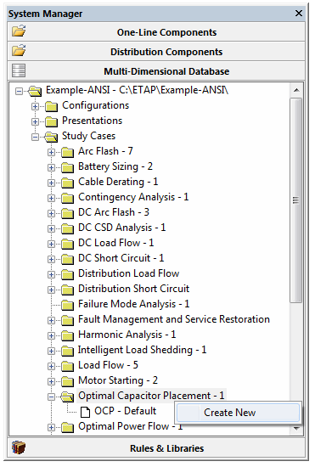
Info Page
The Info page of the OCP Study Case Editor lets you enter general solution parameters and study case information for the OCP study case.
A graphic of the info page and descriptions of the information required for these sections are presented below:
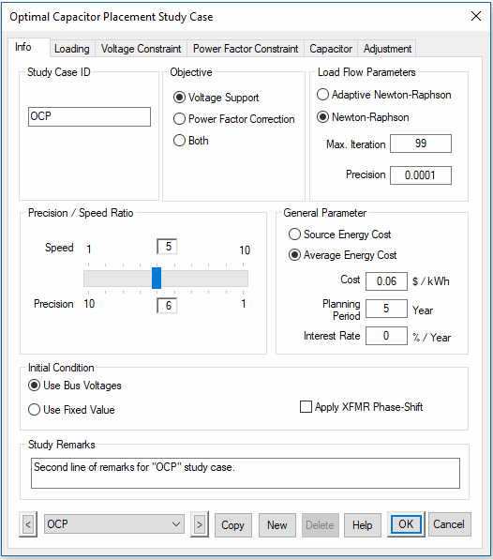
Study Case ID
The study case ID (OCP) is shown in the field in this example. To rename a study case, highlight the text, delete the old ID and enter a new ID. The study case ID field is limited to 25 alphanumeric characters. Use the arrow buttons at the bottom-right of the editor to go from one study case to another.
Objective
In the Objective group select the capacitor placement objective. This allows the OCP module to place capacitors to perform voltage support, power factor correction, or perform both at the same time.
Voltage Support
With this option selected, the OCP module checks only voltage limits and places capacitors to meet the voltage limits when minimizing the cost.
Power Factor Correction
With this option selected, the OCP module checks only load power factor limits and places capacitors to meet the load power factor limits when minimizing the cost.
Both
With this option selected, the OCP module checks voltage limits and load power factor limits, and places capacitors to meet the voltage limits and load power factor limits when minimizing the cost.
Load Flow Parameters
In this group you can set parameters for load flow calculations to control load flow solutions.
Max. Iteration
Enter the maximum number of load flow iterations used to attempt convergence. If the solution does not converge before the specified number of iterations completes, the load flow calculation will stop. If it is running initial load flow calculations, the OCP module will inform you, just as it does in the load flow analysis. However, during the capacitor placement process, the OCP module will abandon the solution if a reasonable capacitor placement does not result.
Precision
Enter the value for load flow solution precision. The OCP module uses this value to check for convergence.
Precision / Speed Ratio
Move the slider to adjust the precision to speed ratio of the OCP study case. Precision and speed are linked inversely. When the speed setting increases from 1 to 10, the precision setting decreases from 10 to 1. The upper value shows the current speed setting. The lower value shows the current precision setting. Position the slider to the left to obtain the optimal solution. Moving the slider to the right will speed up the solution but may yield a less than optimal result.
General Parameter
You can specify cost and control parameters in the General Parameter group.
Source Energy Cost
If you select this option, the energy cost in $/kWh will be calculated from the generation sources.
Average Energy Cost
If you enable this option, an average energy cost value will be used.
Cost
Enter the value for average energy cost ($/kWh) in the Cost field.
Planning Period
Enter the period (years) required to get the maximum benefit by installing capacitors. The OCP module analyzes the cost, saving, and profit achieved during these years.
Interest Rate
Enter the interest rate (%/year) that will be used to calculate the cost, saving, and profit by years.
Initial Condition
Initial conditions for all bus voltages and angles can be specified in this section.
Use Bus Voltages
Select this option to use the bus voltages and angles entered on the Info page of the bus editors. This option allows OCP studies with different initial voltage conditions for different buses.
Use Fixed Value
This option permits simulation of OCP studies using a fixed bus voltage and angle for all buses. When the fixed initial condition option is selected, the initial voltage value must be entered as a percent of the bus nominal voltage. The default values are 100% for bus voltage magnitude and zero degrees for bus voltage angle.
Apply XFMR Phase-Shift
Enable this option to consider transformer phase-shift in load flow calculations. The phase-shift of a transformer can be found in the transformer editor.
Study Remarks
Annotate your output pages in the Study Remarks group. Enter up to 120 alphanumeric characters in this field. Information entered here will be printed on the second line of every output page header line. These remarks can provide specific information for each study case.
Note: The first line of the header information is global for all study cases and is entered in the Project Information editor.

Loading Page
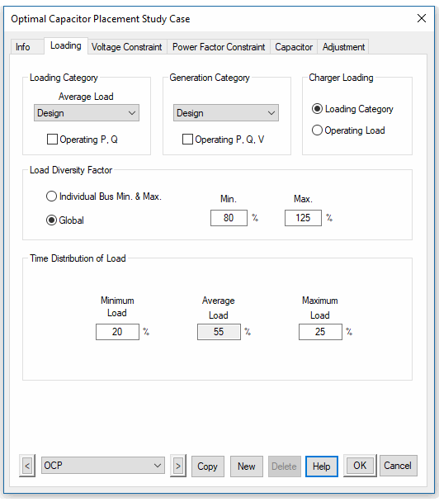
Loading Category
System loading can be specified by selecting a loading category in the Loading Category group of the OCP Study Case Editor.
Average Load
Select one of the loading categories from the Average Load drop-down list for the OCP Study Case.
For any category selected, ETAP uses the percent loading of individual motors and other loads as specified for the selected category.
Note: Assign loading to each one of the ten categories from the Nameplate page of the Induction Machine editor and Synchronous Motor editor and from the Loading or Rating page of the other Load Component Editors.
Operating P, Q
This option is available if the ETAP installation has the Real-Time module activated. When this box is checked, the operating loads uploaded from on-line data, or the previous Load Flow Study, is utilized in the Load Flow Study.
Generation Category
Generation Category
Select one of the ten-generation categories for the OCP study case.
Operating P, Q, V
This option is available if the ETAP installation has the Real-Time Module. When this box is checked, the operating generations uploaded from on-line data, or the previous load flow study, is utilized in the load flow study.
Charger Loading
The option to use loading category load or operating load is available for chargers.

Note: The operating load for a charger can only be updated from a DC Load Flow Study.
Load Diversity Factor
This group allows specific load diversity factors to be applied on the loading category load.
Individual Bus Min. & Max.
When this option is selected, the OCP module uses the individual bus Load Diversity Factor that is specified for each bus. For more information, see the descriptions of the Bus editor in Section 8.1, Bus.
Global
When this option is selected, the OCP module uses a global load diversity factor for all buses. Enter the maximum and minimum global load diversity factor in percentage.
Time Distribution Of Load
Enter the load duration for maximum and minimum load in a percentage of hours per year. The hour for average load is calculated, since the total hour percentage is 100.
Note: You can use the load duration to investigate capacitor placement effects on a power system. When the maximum load duration is not zero, OCP places capacitors to meet a maximum load requirement and displays load flow results for maximum load. If maximum load duration is zero, OCP places capacitors to meet an average load requirement. OCP displays load flow results for an average load. If load durations for both maximum and minimum loads are zero, OCP places capacitors to meet the maximum load requirement, and displays load flow results for a maximum load. In all cases OCP outputs load flow result reports for maximum, minimum and average load.
Example for Using Load Duration to Investigate Capacitor Placement Effect
The load duration may be set for minimum load to 100 so that OCP finds the fixed capacitor banks and sizes for minimum load conditions. Then, the setting may be changed to actual load durations for maximum, minimum, and average loads to find the switched capacitor banks for load levels above the minimum condition up to peak load.
Voltage Constraint Page
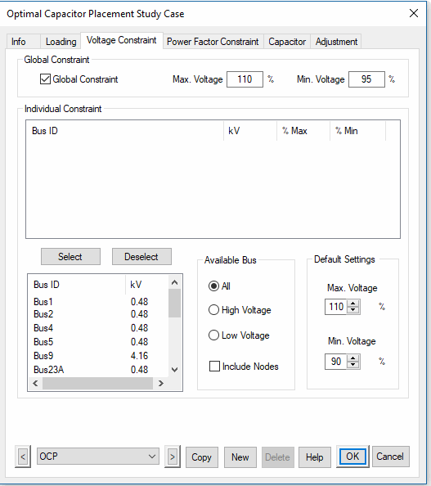
General Constraint
In this group, you can specify general voltage constraint for maximum and minimum voltages.
General Constraint
When General Constraint is selected, enter the percentage values for maximum and minimum voltages.
Maximum Voltage
The Maximum Voltage is the global limit (in percent) for the maximum voltage of all buses, except the ones selected for the Individual Constraint list.
Minimum Voltage
The Minimum Voltage is the global limit (in percent) for the minimum voltage of all buses, except the ones selected for the Individual Constraint list.
Individual Constraint
This group displays information on all the selected buses, including the Bus ID, kV rating, and maximum and minimum voltage. The global constraint does not apply to these buses.
Select/Deselect Buttons
- Highlight a bus from the list box underneath the buttons. This box initially lists all the buses in the system for the specified Available Bus option.
- Click the Select button to move the highlighted bus into the Individual Constraint box.
Note: Highlighting a bus in the Individual Constraint box, and clicking the Deselect button, moves that bus into the list box underneath the button to let the bus use global constraints.
Available Bus
You can specify which of the available buses will be visible in this group.
All
Show all buses in the system.
High Voltage
Show all buses in the system whose rated voltage is higher than 1 kV.
Low Voltage
Show all buses in the system whose rated voltage is equal to or lower than 1 kV.
Include Nodes
Check this box to include nodes as buses.
Default Settings
This group sets the voltage limits for the buses that are selected for the Individual Constraint list.
Max. Voltage
This option sets the maximum voltage limit in percent.
Min. Voltage
This option sets the minimum voltage limit in percent.
Power Factor Constraint Page
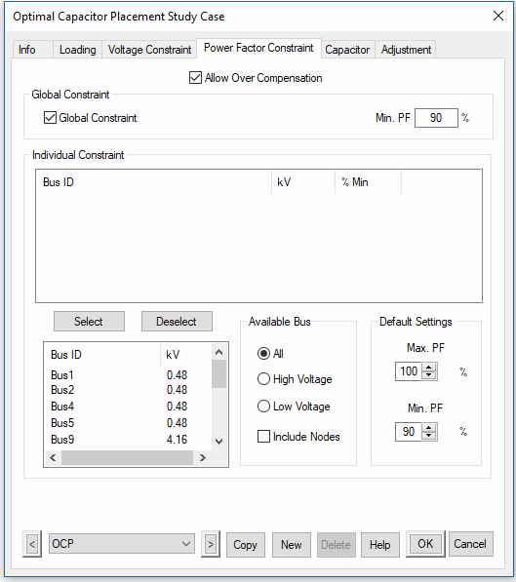
Allow Over Compensation
If this option is selected, when it is economically justified the OCP Module may place capacitors to supply a level of reactive power that is more than the load’s reactive power demand at that bus. If this option selected, the maximum power factor constraint is not applied.
General Constraint
This group allows you to specify general constraints for the maximum and minimum power factor. By selecting General Constraint, you can enter the values for maximum and minimum power factors.
Max. PF
The maximum power factor is the global limit for the maximum power factor of all buses, except the ones selected for the Individual Constraint list. Max Power Factor is not available when you enable Allow Over Compensation.
Min. PF
Min Power Factor is the global limit for the minimum power factor of all buses, except the ones selected for the Individual Constraint list.
Individual Constraint
This box lists information about all the selected buses, including the Bus ID, kV rating, and maximum and minimum power factor in percentage. The global constraint does not apply to these buses.
Select/Deselect Buttons
- Highlight a bus from the box beneath the buttons. This box initially lists all the buses in the system for the specified Available Bus option.
- Click the Select button to move the highlighted bus into the Individual Constraint box.
Note: Highlighting a bus in the Individual Constraint box and clicking the Deselect button moves that bus into the box beneath the button so that the bus uses global constraints.
Available Bus
Use this group to specify which of the available buses will be visible.
All
Shows all buses in the system.
High Voltage
Shows all buses in the system with rated voltage higher than 1 kV.
Low Voltage
Show all buses in the system with rated voltage equal to, or lower than 1 kV.
Include Nodes
Select this box to include nodes as buses.
Default Settings
This group allows the power factor limits for the buses which will be selected for the Individual Constraint to be specified.
Max. PF
Specify the maximum power factor limit (in percent).
Min. PF
Specify the minimum power factor limit (in percent).

Capacitor Page
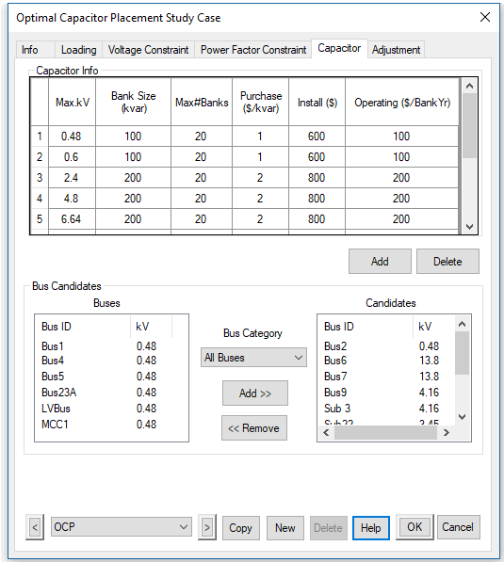
Capacitor Info
Allow entering specific capacitor related information in this group. Each numbered row provides rating, bank size and pricing information organized from lowest to highest Max. kV for each type of capacitor.
Max. kV
Enter the maximum possible rated voltage level (in kV) to which this type of capacitor can be used.
Bank Size (kVar)
Enter the bank size in kVar for this type of capacitor.
Max#Banks
Enter the maximum number of banks that can be installed at a bus using this type of capacitor. The default maximum value is 30. However, this limit can be increased using the MaxCapOCP setting accessible through ETAP Preferences.
Purchase ($/kVar)
Enter the purchase cost in $/kVar of this type of capacitor.
Install ($)
Enter the installation cost of this type of capacitor for one location.
Operating ($/BankYr)
Enter the operating cost in $ per bank, per year, of this type of capacitor.

Note: The cost is for the current year and the Interest Rate is considered during the planning period.
Add
Add new capacitor information.
Delete
Delete the highlighted capacitor information.
Bus Candidates
Buses
Shows all available buses in the Bus Category option.
Bus Category

All Buses | Shows all buses in the system.
HV Buses | Shows all buses in the system whose rated voltage is higher than 1 kV.
LV Buses | Shows all buses in the system whose rated voltage is equal to or lower than 1 kV.
HV SWGR | Shows all switchgear buses in the system whose rated voltage is higher than 1 kV.
LV SWGR/MCC | Shows all switchgear and MCC buses in the system whose rated voltage is equal to or lower than 1 kV.

Candidates
Lists all candidates for capacitor installation.
Note: Use the Add and Remove buttons to add or remove bus candidates.

Adjustment Page
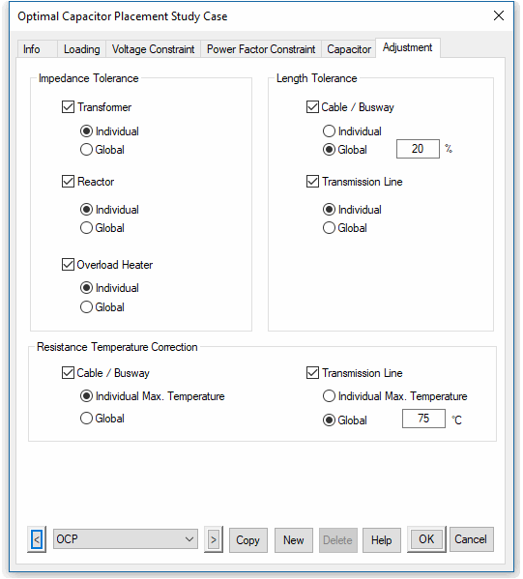
The page allows you to specify the adjustment settings. Adjustments are typically used for load flow studies. Please check the unbalanced load flow adjustment page for more details.

Display Options
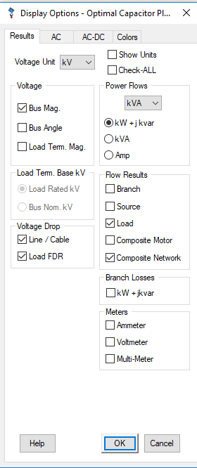
There are results, AC, AC-DC, and Colors page. Here will introduce Results page. For the other pages, please check Unbalanced Load Flow Display option session for details.
Results Page
Assign display annotations for each study on the results page.
Show Units
Select this option to show units for displaying power flow and current on the one-line diagram.
Check All
Select this option to show all available result annotations.
Note: When this box is cleared, all previous settings are restored.
Voltage
This group defines how the voltage is displayed.
Voltage
To select how the voltages will be displayed on the one-line diagram select either kV, or percent, from the dropdown list.
Bus Mag.
Select this option to display bus voltages on the one-line diagram.
Note: Bus voltages are displayed at 15 degrees.
Bus Angle
Select this option to display bus angle (in degrees) on the one-line diagram.

Note: Bus voltage angles are displayed at -15 degrees.
Load Term. Mag.
Select this option to display load (motors, lump loads, and static loads) terminal voltages on the one-line diagram.

Note: Load terminal voltages are displayed at 15 degrees. Load terminal voltages based on load rated kV or bus nominal kV can be displayed, depending on the selection in Load Term. Base kV.
Load Term. Base kV
This group allows a base kV for load terminal magnitude to be selected, when the voltage is displayed as a percentage.

Note: This group will be disabled if kV is selected as the voltage display.
Load Rated kV
Select this option to use load rated kV as the base for load terminal voltage display.
Bus Nom. kV
Select this option to use bus nominal kV as the base for load terminal voltage display.
Voltage Drop
This group lets you configure how the voltage drop is displayed.
Line / Cable
Select this option to display line and cable voltage drops on the one-line diagram.
Load FDR
Select a unit for power flow, or current flow from the list to be displayed on the one-line diagram.
Power Flows
This group lets you configure how the power flows are displayed.
Units
Select the unit (kVA or MVA) to be used to display power flow on the one-line diagram.
kW + jkVar
Select the kW + jkVar option to display power flow in kW+jkVar or MW+jMVar.
kVA
Select the kVA option to display power flow in kVA or MVA.
Amp
Select the Amp option to display current flow in amperes.
%PF
When either the kVA or Amp option selected; the power factor of power flow shows along with the current.
Flow Results
This group lets you configure how the flow results are displayed.
Branch
Select this option to display power flow through all branches on the one-line diagram. ETAP displays the power flow at one end of a branch (the end that has a positive kW value flowing into the branch). For 3-winding transformers, all three power flows are displayed.
Source
Select this option to display power flow for generators and power grids on the one-line diagram.
Load
Select this option to display power flow for motors, MOVs, capacitors, lumped loads, and static loads on the one-line diagram.
Composite Motor
Select this option to display power flow into composite motors.
Composite Network
Select this option to display power flow into composite networks.
Panel System
Select this option to display results for panel systems on the one-line diagram, assuming the Calc. Panel System option is selected, in the study case when the load flow calculation was performed.
Note: If the Calc. Panel System option was not enabled in the load flow study case, or in the Panel System display option, no result will be displayed on the one-line diagram.
Branch Losses
Select this option to display branch losses on the one-line diagram.

Note: Losses are displayed inside a bracket in [kW+jkVar] or [MW+jMVar].
Meters
This group lets you configure how the meters are displayed.
Ammeter
Select this option to display the primary current for the branch to which an ammeter is attached.
Voltmeter
Select this option to display the primary voltage for the bus to which a voltmeter is attached.
Multi-Meter
Select this option to display the measurements of a multi-meter, including bus voltage, branch current, branch power flow, power factor, and frequency.

Output Reports
Optimal capacitor placement calculation results are reported on the one-line diagram and in Crystal Reports format. The one-line diagram displays bus voltages, branch flows and voltage drops, and load power consumption for maximum, minimum, or average load that are generated as a result of the calculation.
Use the Display Options editor to specify the content to be displayed. The one-line diagram also displays new capacitor information, which includes the total number of banks, rated kV, rated kVar, operating kVar, and amps.
The Crystal Reports format provides reports containing detailed information about capacitor installation and load flow analysis. Use the OCP Report Manager to view the output report.
Study Case Toolbar
The Study Case toolbar provides a shortcut for the OCP Report Manger options.
- Click the List Output Reports button.
ETAP automatically opens the List Output Report dialog box, and displays the output report listed in the Study Case toolbar in your selected format. In the example toolbar shown below, the output report name is OCP and the selected format is Cable.
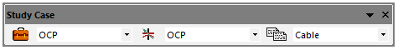
Report Manager
The OCP Report Manager includes four pages, which represent different sections of the output report. They are as follows:
- Complete
- Input
- Result
- Summary
Click the Report Manager button on the Optimal Capacitor Placement toolbar. The OCP Report Manager lets you select from the listed formats for each section of the report.
Use the column of radio buttons on the right of the dialog to select the report format in which to view (Viewer, PDF, MS Word, and more).
Several fields and buttons are common to every page.
Output Report Name
This field displays the name you entered for the output report. .
Path
This field displays the name of the project file, depending on which report was generated, along with the directory where the project file is located.
Help
Click this button to access Help.
OK / Cancel
Click OK to close the OCP Report Manager and display the Crystal Reports view. This shows the selected section of the output report.
Note: the OCP Report Manager will close if no selection is made.
Click Cancel to close the OCP Report Manager without viewing the report.
Complete Page
Selecting Complete in the left column of this page will cause all reports to be printed in the format you have selected.
Input Page
The input data is grouped according to the data types listed below.
- Adjustments
- Branch
- Bus Constraints
- Bus
- Cable
- Capacitor Info Data
- Cover
- Impedance
- Reactor
- SVC
- Transformer
Sample 1: Input Data
This section lists system input parameters for buses, transmission lines and cables, transformers, reactors, impedances, and all connections including tie circuit breakers, fuses, and switches.
Result
This page allows different formats to be selected to view the result report. These formats include:
- LF Report Average
- LF Report Maximum
- LF Report Minimum
- OCP Results
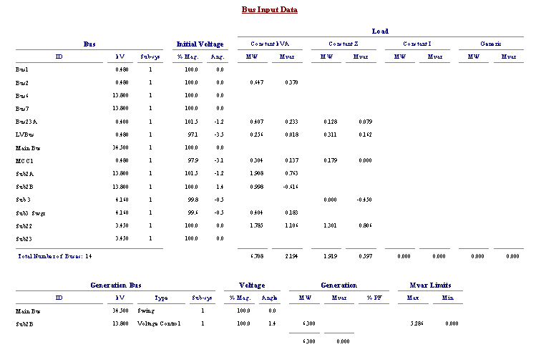
Sample 2: Load Flow Report
This section of the report tabulates detailed load flow results. The results reported include:
- Bus ID and nominal kV
- Calculated voltage magnitudes and angles
- MW and MVar generation and loading
- Branch flows from the bus to all buses connected to it
Flows are given in MW and MVar, amps, and %PF measured at the bus. Flows into 3-winding transformers are indicated as flows from one of the bus windings to the other two bus windings (from Main Bus to Sub 2B and Sub 3).
The settings of tap-changing transformers are also indicated at buses to which a tap side is connected. These tap settings include the fixed taps and results from the LTCs. Regulated (voltage-controlled) buses are flagged with an asterisk (*).
Load flow results are reported for average, maximum, and minimum loads.
Sample 3: OCP Results Report
This section of the report tabulates capacitor placement results. The results reported include:
- Bus ID
- Nominal kV
- Calculated voltage magnitudes and angles
- Power factor and capacitor bank information (capacitor rated kV, rated kVar per bank, total number of banks installed, installation cost, total purchase cost, and total operation cost)
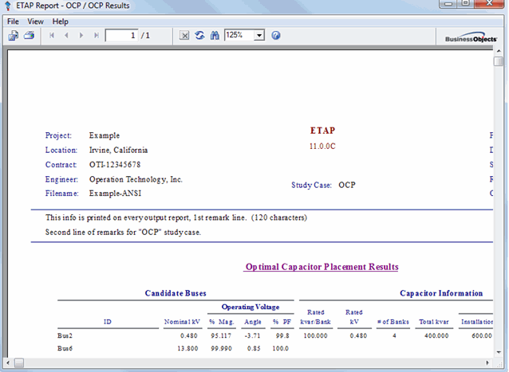
Summary Page
This page allows different formats to be selected to view the Result Summary Report. They are as follows:
- Branch Capacity Release
- Branch Loading
- Bus Loading
- Losses
- OCP Cost Summary
- Summary
Sample 4: OCP Cost Summary Report
This section of the report tabulates the system cost information. The information summarizes the cost for each year during the planning period. The costs include installation cost, operation cost, savings, and profit.
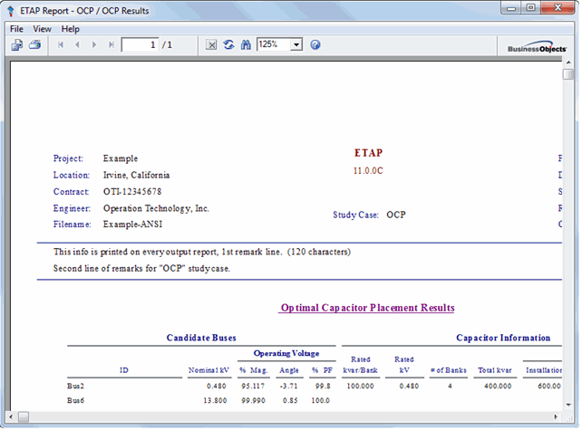
Note: The interest rate is considered for the calculation.
Sample 5: Branch Capacity Release Report
Branch capacity release is the MVA difference of the branch before and after the capacitors are installed.
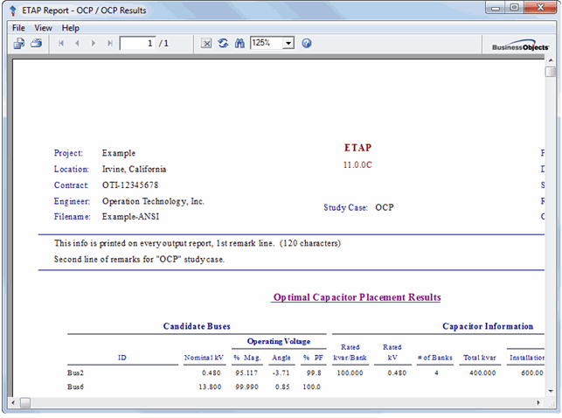

Plots
Report data can be plotted using three different curves. These curves consist of:
- Loss Reduction Saving During Planning Period ($)
- Capacitor Operation Cost During Planning Period ($)
- Profit During Planning Period ($)
Click the Plot button on the Optimal Capacitor Placement toolbar to plot report data.
The Optimal Capacitor Placement Plot Selection dialog box appears. A combination of plots may be selected from the list of check boxes
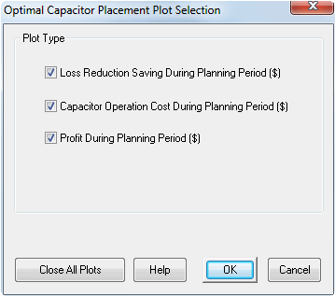
Loss Reduction Saving During Planning Period
This plot shows savings in dollars due to loss reduction vs. years. When interest is considered, the actual saving will increase as a function of time.
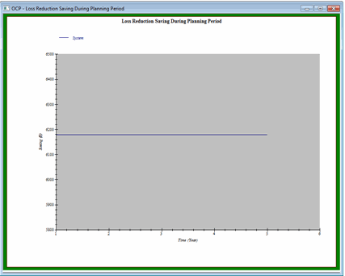

Capacitor Operating Cost During Planning Period
This plot shows the operating cost in dollars vs. years. When interest is considered, the actual cost will increase as a function of time.
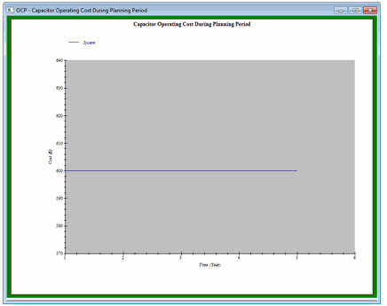

Profit During Planning Period
This plot depicts profit in dollars vs. years. The savings accrued each year will be used to pay off the operating cost and installation cost. Any unpaid dollars is considered as fixed cost for the following year.
A positive profit can be yielded when the loss reduction saving is bigger than the operating cost for each year.
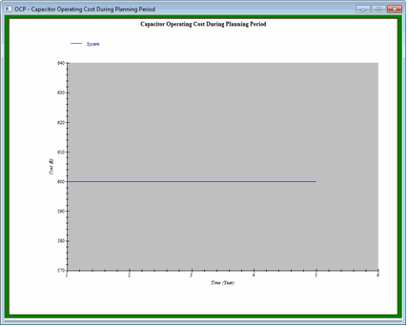
Note: The purpose of placing capacitors is not entirely about making profit. It is possible that profit may be negative during the entire planning period for some systems.

PSMS Typical
This section describes the typical elements to be used for ETAP PSMS Model.

Power Grid
The power grid symbol is shown below.


Bus
The bus symbol is shown below.

Generator
The generator symbol is shown below. Note: the ANSI Generator symbol is preferred to be used as it follows an international standard

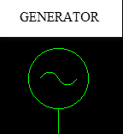

Transformer
Transformer symbols are shown below.

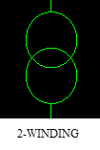 | 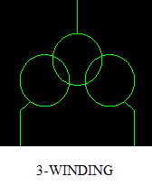 | 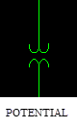
 | 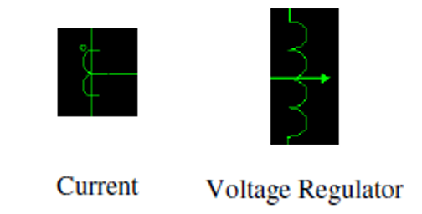

High voltage circuit breaker
The symbol for a high voltage circuit breaker (>1kV) is shown below.
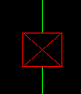 | 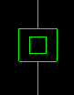
Closed Breaker | Open Breaker

Switch
The switch symbol is shown below.
 |  |  | 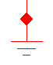
Open Switch | Closed Switch | Open Ground Switch | Closed Ground Switch

Lumped Load
The lumped load symbol is shown below.


Multi-Meter
The Multi Meter symbol is shown below. Note: there is an option to hide/unhide this component if desired.
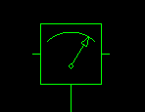

Capacitor Bank
The Capacitor Bank symbol is shown below.
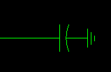

Cable
The Cable symbol is shown below.
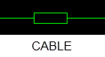

Low Voltage Circuit Breaker
The Low Voltage Circuit Breaker symbol is shown below.
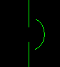

Induction Motor
The Induction Motor Symbol is shown below.


Factory Acceptance Test
The scope of the Factory Acceptance Test (FAT) is to demonstrate that the system complies with the requirements specified for the operation of the system.

The FAT will include the following

  - Prove communication with TNB SCADA system
  - Prove that data mapping is correct between ETAP and TNB SCADA system
  - Prove that control could be sent from ETAP to TNB SCADA system
  - Prove the communication between ETAP RT Server and ETAP RT Consoles
  - Prove DSE engine functionality with real time data
  - Prove VVO engine functionality with real time data

User Acceptance Test
The purpose of this document is to list all the tests that will be carried out and the procedure that will be adopted during the User Acceptance Testing of the ETAP Real-Time System. The purposes of this test:

  - Verify communication with TNB SCADA System
  - Verify the communication between ETAP Real Time-Servers and ETAP Real-Time Consoles
  - Verify the DSE results are valid and reasonable
  - Verify that VVO recommendations could be sent manually as well as automatically based on specified constrains
  - Verify that loss report and voltage range report could be generated from VVO web view

